# 001_PORT: Individual UI/UX Portfolio

Name: Marwan Ashhuby

Student Number: 202244071

Date: 28/03/25

## Part 1 - Cognitive walkthrough of existing UI/UX case studies

For the first part of this report, three cognitive walkthroughs will be conducted to estimate the efficiency of chosen case studies in their usability from a user’s perspective.

The chosen case studies are:

* University of Hull’s Hubble student portal (with two different user goals)
* Sennheiser Smart Control app

The goals of the cognitive walkthroughs will be explained in the relevant segments as well as assumptions taken.

Questions asked during the cognitive walkthrough are answered with either:

* Yes
* Mostly
* Partially
* No

### A student seeking mental health support

**Assumptions:**

* The user is a valid student and is successful logged in.
* The student starts at the [Hull Student Portal](https://hull.service-now.com/student).
* They may be feeling overwhelmed, anxious, or in urgent need of help.
* They might not know the exact terminology to search for (e.g., “wellbeing” vs “mental health”).

#### A screenshot of a computer AI-generated content may be incorrect.Cognitive Walkthrough: Step 1 – Landing on the Hubble Portal

Vague titles (negative)

Consistent text size, font and text formatting as well as tile shape and size (Positive)

Organized tile layout (positive)

Green background confirmation when hovering (positive)

User Goal:

Access mental health support via the University of Hull Hubble Portal.

Screenshot Context:

The user is on the main landing page of the Hubble Portal. Several tiles are displayed, one of which is labelled "Inclusion and Wellbeing". The green colour is shown only due to mouse hover.

Step 1 Interaction

Action:  
Click on "Inclusion and Wellbeing" to proceed toward mental health support.

Cognitive Walkthrough Questions:

1. Will the user try to achieve the right effect?

Yes

The user is looking for help with mental health. The word “Wellbeing” matches that goal. There are brief descriptions beneath the titles of the tiles that should confirm this to the user.

2. Will the user notice that the correct action is available?

No

The tiles are not made obvious that they are buttons to redirect users at first glance, this is not until the user hovers the mouse over the tile which changes its colour which suggests it is clickable.

With no distinctive colour or icon before hover, the tile might not stand out unless the user reads every option carefully.

The tile is still part of a clear grid, but nothing visually prioritizes it over others before interaction.

3. Will the user associate the correct action with the effect they are trying to achieve?

No

The term “Wellbeing” helps, but the pairing with “Inclusion” could introduce doubt (i.e., might this be about diversity support rather than mental health?).

Users in distress or in a hurry may not confidently associate this with mental health services. It isn’t until the user reads the tiles description that they are confident this tile is the correct option for them.

4. If the correct action is performed, will the user see that progress is being made toward their goal?

Yes

Clicking the tile leads (changes webpage) to more specific categories or resources, so feedback is immediate and relevant.

|  |  |  |  |  |
| --- | --- | --- | --- | --- |
| Issue | Description | Severity | Heuristic Violated | Suggested Improvement |
| Visual feedback only on hover | Tile only changes colour on mouse hover, which isn’t useful on touch devices and may not be noticed. | Medium | Visibility of system status | Use persistent visual indicators or hover alternatives (e.g. icons or titles) to show active/interactable tiles. |
| Vague tile labels | Tile names like “Wellbeing & Inclusion” are not intuitive or action-oriented for users seeking mental health help. | High | Match between system and real world | Use clearer, action-driven labels like “Get Mental Health Support” or “Talk to Someone.” |
| Overload of choices | The dashboard displays many tiles with no hierarchy or grouping, making it hard to identify the correct one. | Medium | Aesthetic and minimalist design | Group similar services and prioritize frequently used actions like support access. |
| No immediate guidance | There is no onboarding, tooltip, or search suggestion for users who may not know what to click. | Medium | Help users recognize, diagnose, and recover from errors | Add a simple “Need help?” or “Find Support” guide or shortcut to support services. |

|  |  |
| --- | --- |
| **Positive Observation** | **Heuristic Followed** |
| The tiles are arranged in an easy-to-scan, basic grid-like manner. | **Aesthetic and minimalist design** - A simple layout makes it easier for users to concentrate without feeling overloaded. |
| Tiles are highlighted in green when hovered over. | **Visibility of system status** -provides instant confirmation that the tile is interactive. |
| Consistent size, shape, and behaviour across all tiles | **Consistency and standards** - The tiles' behaviour doesn't need to be relearned by users. |
| Minimal amount of text clutter at the beginning | **Aesthetic and minimalist design** - lessens the mental strain on novice users. |

Summary of Step 1

|  |  |  |
| --- | --- | --- |
| Evaluation Point | Rating | Notes |
| Right effect understood | Yes | Clear mental health goal matches “Wellbeing” |
| Correct action visible | No | No strong visual cue until hover |
| Correct mapping | No | “Inclusion” might cause hesitation |
| Feedback provided | Yes | User is taken to appropriate next steps |

#### A screenshot of a computer AI-generated content may be incorrect.Cognitive Walkthrough: Step 2 – Inside "Inclusion and Wellbeing"

Options are positioned front and centre where human eyes naturally first look (positive)

Unused space (negative)

Vague titles (negative)

No descriptions (negative)

User Goal:

Access mental health support services.

Screenshot Context:

The user has entered the "Inclusion and Wellbeing" section. On screen, several large rectangular tiles are shown, including:

* Raise a concern
* Student Services and Support
* Wellbeing and Inclusion

These tiles change colour (e.g., green) only when hovered over, not when selected.

Step 2 Interaction

Action:  
Click on "Wellbeing and inclusion" tile.

Cognitive Walkthrough Questions

1. Will the user try to achieve the right effect?

Partially

The user likely assumes that “Wellbeing & inclusion” might relate to mental health support. However, this assumption is based on guesswork due to the vague naming. It is quite obvious that the user should choose between the tiles on screen.

2. Will the user notice that the correct action is available?

Partially

The tile is visible and responds to mouse hover (changes green), but:

* There’s no visual indicator of importance or priority.
* No descriptions or icons make it unclear what exactly each tile leads to.
* All tiles look visually equal, which doesn't guide the user’s attention.
* Tiles are very small and should take it much more space on screen.
* Descriptions of what each tile refers to is also missing.

3. Will the user associate the correct action with the effect they are trying to achieve?

Partially

The phrase "Health & Wellbeing" is somewhat aligned with mental health, but it’s broad and non-specific.

Users seeking urgent or specific support (e.g., mental health crisis) may not be confident this is the right place.

4. If the correct action is performed, will the user see that progress is being made toward their goal?

Yes

Assuming they click it, it will bring them closer to the correct support path — but it depends on their understanding that this is the correct choice.

Observed Usability Issues

|  |  |  |  |  |
| --- | --- | --- | --- | --- |
| Issue | Description | Severity | Heuristic Violated | Suggested Improvement |
| Lack of labels/descriptions on tiles | Each tile lacks supporting text or icons, making it unclear what action will occur when clicked. | High | Recognition rather than recall | Add short descriptions or icons under each tile to clarify their purpose. |
| All tiles have similar design priority | Tiles are uniform in colour, size, and emphasis, giving no guidance on which is more important. | Medium | Aesthetic and minimalist design | Use visual hierarchy (e.g., colour, size, position) to highlight key services like mental health support. |
| Vague wording (e.g., "Student Services and Support") | Labels are too broad and can be misinterpreted or overlooked by users in need of specific help. | High | Match between system and real world | Rename tiles to more action-oriented or specific phrases like “Get Mental Health Support” or “Speak to a Counsellor.” |
| No hover/click feedback beyond colour | The only interaction feedback is a colour change on hover, which may not be accessible or obvious to all users. | Medium | Visibility of system status | Add icons or animated hover states to reinforce that the tile is interactive. |
| No clear entry point for urgent support | There is no standout option for users in crisis or needing immediate support. | High | User control and freedom | Perhaps a radical suggestion but adding a distinct tile (e.g., “Need urgent help?”) in a different colour or position to guide those users quickly would bypass a lengthy process to get students in urgent need help quicker. |

|  |  |
| --- | --- |
| **Positive Observation** | **Heuristic Followed** |
| Under one division, related services are organized together (Mental Health, Disability, etc.). | **Match between system and the real world** — Users can better grasp how the system corresponds to real-world categories by grouping comparable content. |
| The way tiles interact (hover highlighting, etc.) is constant. | **Consistency and standards** — minimizes learning effort and maintains a consistent user experience. |
| Distraction-free, simple, and minimalist page design. | **Aesthetic and minimalist design** — eliminates extraneous details and concentrates exclusively on the most crucial aspects. |
| Users can swiftly go to the desired service with tile-based navigation. | **Flexibility and efficiency of use** — Tiles speed up common tasks by acting as shortcuts. |

Summary of Step 2

|  |  |  |
| --- | --- | --- |
| Evaluation Point | Rating | Notes |
| Right effect understood | Yes | Though based more on guessing than clarity |
| Correct action visible | Partial | Tile is visible, but not clearly *the* right one |
| Correct mapping | Partial | Label is vague; could cause hesitation |
| Feedback provided | Yes | Clicking progresses toward goal |

#### A screenshot of a computer AI-generated content may be incorrect.Cognitive Walkthrough: Step 3 – Health & Wellbeing Section

Favouriting system for returning users to quickly find frequently used pages (positive)

Easy to navigate grid system (positive)

All options have same priority which makes it hard to find more commonly accessed articles (negative)

User Goal

Find and access mental health support services.

Screenshot Context

The user has now entered the Health & Wellbeing page. Several blue clickable links are displayed, such as:

* Payment of tuition fees
* General enquiry form
* Report a concern
* Support for neurodivergent students

Step 3 Interaction

Action:  
Click the "Mental Health Support" article.

Cognitive Walkthrough Questions

1. Will the user try to achieve the right effect?

Yes

The user is now clearly presented with a direct link to "Mental Health Support". This matches their intention precisely.

2. Will the user notice that the correct action is available?

Mostly

The link is visible and labelled clearly, but:

* It’s buried among many similar blue text links and can be very hard to spot.
* There’s no icon, emphasis, or structure to highlight more urgent or critical options like “Mental Health Support.”
* If the user is in distress or anxious, the lack of clear hierarchy might make it harder to quickly spot.

3. Will the user associate the correct action with the effect they are trying to achieve?

Yes

“Mental Health Support” is explicit and unambiguous. There's no confusion about what it offers.

4. If the correct action is performed, will the user see that progress is being made toward their goal?

Yes

Clicking will take the user to a page for accessing support services.

Observed Usability Issues

|  |  |
| --- | --- |
| Issue | Impact |
| Poor visual hierarchy | All links are same style; urgent items not emphasized |
| Lack of icons or structure | Reduces scannability and quick decision-making |
| Small body text and intro | Key context may be missed or skipped |

|  |  |  |  |  |
| --- | --- | --- | --- | --- |
| Issue | Description | Severity | Heuristic Violated | Suggested Improvement |
| Tiles are vague and generic | Similar to the dashboard, the tiles here don’t clearly signal what each option leads to — there’s too much guesswork. | High | Recognition rather than recall | Use more descriptive titles or subtitles, e.g., “Mental Health – Get Help Now.” |
| No hover alternatives | Important for mobile/touch users — the hover effect showing green doesn’t help on touchscreens. | Medium | Flexibility and efficiency of use | Include icons or brief descriptions on tiles that are always visible. |
| No filtering or sorting | There’s no option to sort/filter support topics, which could help a user in crisis find help faster. | High | User control and freedom | Add filters like “Urgent Help,” “Counselling,” “Academic Support,” etc. |
| No search bar provided | Even if a student knew exactly the section they would like to find, there is no option to search for it. | Medium | Help and documentation | Add obvious search bar at the top of the tiles. |

|  |  |
| --- | --- |
| **Positive Observation** | **Heuristic Followed** |
| Detailed written instructions on how to obtain assistance (such as completing the self-referral form) | **Match between system and the real world** — Makes use of simple, understandable language that is natural. |
| Important instructions are included in the advisory text, such as the link to the self-referral form. | **Recognition rather than recall** — Users don't need to recall individual steps to take action. |
| There are several ways to get help (self-referral form, helpline number, app). | **User control and freedom** — Various routes to assistance are provided to users based on their preferences. |
| Details regarding the following steps (e.g., contact within 5 working days) distinctly set | **Visibility of system status** — Users' nervousness is decreased by informing them of what will happen once they finish the form. |

Summary of Step 3

|  |  |  |
| --- | --- | --- |
| Evaluation Point | Rating | Notes |
| Right effect understood | Yes | Link directly reflects user intent |
| Correct action visible | Mostly | Visible, but not emphasized or easy to scan |
| Correct mapping | Yes | Clear language used |
| Feedback provided | Yes | Clicking progresses directly to support |

#### A screenshot of a computer AI-generated content may be incorrect.Cognitive Walkthrough: Step 4 – Accessing mental health and wellbeing support article

Huge block of text (negative)

Semi hidden link to form (negative)

Multiple options for students depending on the situation (positive)

User Goal:

Find the form to get mental health assistance.

Screenshot Context

The student has clicked on the ‘Accessing mental health and wellbeing support’ tile, which redirects them to an article. The article is a large block of text sectioned into multiple paragraphs each as its own option for the student:

* Contact the mental health and wellbeing team
* Student assistance programme

Cognitive Walkthrough Questions

1. Will the user try to achieve the right effect?

Partially

The user may not realise the option to proceed from this page as no immediate suggestion is given. It cannot be confidently said that a student would know to click a link without reading through the entire page; There is a lack of a clear call-to-action that may cause hesitation.

2. Will the user notice that the correct action is available?

Partially

The link to get to the ‘self-referral form’ is somewhat hidden amongst text. The fact it is underlined is the only reason the user has to assume it is a clickable link. This forces the user to read big blocks of text before finding the correct action. A student who is not in the most stable mental state who skims the page to urgently attempts to get assistance would not immediately notice the link to proceed to the next step.

3. Will the user associate the correct action with the effect they are trying to achieve?

Yes

Obvious and unambiguously, the page states “If you would like to access support for your mental health or wellbeing, please fill out our self-referral form.”, with the underlined portion being a link to the form (final step).

4. If the correct action is performed, will the user see that progress is being made toward their goal?

Yes

The user is immediately redirected to the self-referral form, the transition confirms to the user that they are progressing successfully in their user goal.

Observed Usability Issues

|  |  |  |  |  |
| --- | --- | --- | --- | --- |
| Issue | Description | Severity | Heuristic Violated | Suggested Improvement |
| Lack of clear call-to-action | The self-referral link is buried in a paragraph and not visually distinct, which may prevent users from noticing it. | High | Visibility of system status / Recognition rather than recall | Use a prominent button or banner labelled "Access Support" or "Fill Out Self-Referral Form." |
| Poor scannability of content | Users must read large blocks of text to locate the next step. This is especially problematic for distressed students who may not read carefully. | High | Aesthetic and minimalist design | Use headings, bullet points, or bolded keywords to break up content and guide attention. |
| Ambiguous clickable element | The link is only distinguishable by being underlined, which is easy to overlook in a long paragraph. | Medium | Match between system and real world | Turn the link into a clearly styled button to match common design patterns users expect. |
| No feedback until redirection | The system provides no indication that the user is progressing until the page changes. | Low | Visibility of system status | Include a brief message like “Redirecting to referral form…” after clicking. |

|  |  |
| --- | --- |
| **Positive Observation** | **Heuristic Followed** |
| Different forms of support are distinguished by distinct headers ("Contact the Mental Health and Wellbeing team," "Student Assistance Programme"). | **Recognition rather than recall** — Headings make it simple to swiftly locate pertinent sections without having to read them all. |
| Without requiring further clicks, external support alternatives (such as the SAP hotline and app) are displayed immediately. | **Flexibility and efficiency of use** — Various users (casual versus urgent help-seekers) can obtain what they need in a short amount of time. |
| layout that is consistent with other Knowledge Base articles (right "Most Useful" panel, left content) | **Consistency and standards** — Maintains consumers' experiences with the portal consistent and comfortable. |
| There is clear direct access to other materials via a link ("go to our website"). | **User control and freedom** — If necessary, viewers can simply decide to look for more in-depth information outside of the Hubble portal. |

Summary of Step 4

|  |  |  |
| --- | --- | --- |
| Evaluation Point | Rating | Notes |
| Right effect understood | Partially |  |
| Correct action visible | Partially |  |
| Correct mapping | Yes |  |
| Feedback provided | Yes |  |

#### Cognitive Walkthrough: Step 5 – Submitting the self-referral form.

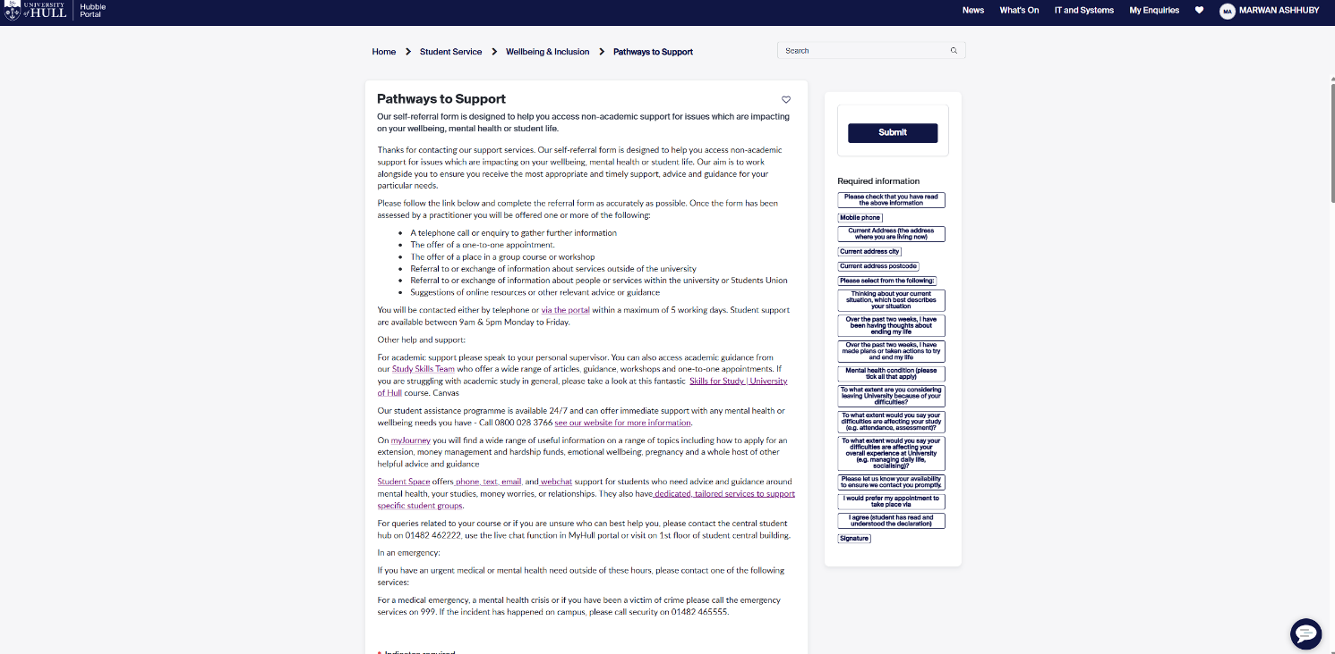

Huge block of text (negative)

Gives students relevant information of what will happen after submitting BEFORE filling in the form (positive)

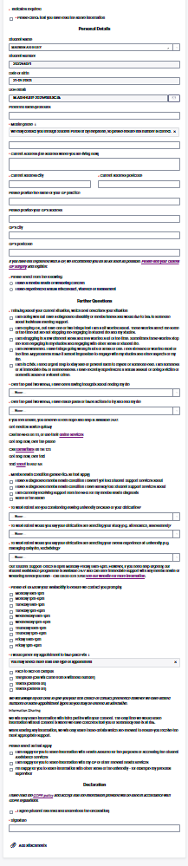

Very long form to fill out (negative)

User Goal:

Fill the form to get mental health assistance.

Screenshot Context:

Once the link has been pressed, the student is taken to the page with the   
form to self—refer mental health assistance.

Cognitive Walkthrough Questions

1. Will the user try to achieve the right effect?

Mostly

The user is aware that in order to receive mental health support, they must fill out the form. Motivated users will attempt to continue because the form title and introduction content make this evident. However, the length could overwhelm people who are already under stress, discouraging them from finishing it all.

2. Will the user notice that the correct action is available?

Yes

The user is obviously supposed to complete the form. The "Submit" button is positioned prominently at the top right, and fields are instantly visible. A form's structure strongly suggests action.

3. Will the user associate the correct action with the effect they are trying to achieve?

Yes

The page makes it very evident that filling out the form will start the process of getting in touch with someone for mental health support. The user is likely to believe that completing and submitting the form is the proper way to obtain assistance.

4. If the correct action is performed, will the user see that progress is being made toward their goal?

Yes

Following submission, there is instantaneous, unambiguous confirmation (thank you page and email confirmation). Users should feel confident that their action was successful because they receive strong feedback.

|  |  |  |  |  |
| --- | --- | --- | --- | --- |
| **Issue** | **Description** | **Severity** | **Heuristic Violated** | **Suggested Improvement** |
| Form is visually overwhelming | Users, particularly those who are distressed, may feel intimidated by the form's lengthy and thick appearance. | High | Aesthetic and minimalist design | Create a progress indicator and divide the form into several smaller pages (multi-step form). |
| Absence of explicit mistake prevention | Absence of obvious real-time validation (such as phone number formats or missing fields). | Medium | Error prevention | When mandatory fields are filled out incorrectly or incompletely, provide immediate feedback. |
| Text conceals important assistance information. | When immediate assistance is required, emergency contact information is difficult to find since it is hidden within paragraphs. | High | Visibility of system status | Use icons or coloured boxes to draw attention to the emergency contact information independently at the top. |
| Tiny clickable regions (radio buttons, checkboxes) | Small clickable targets in some options (such "I give permission to share information") could irritate consumers. | Low | Flexibility and efficiency of use | Make clickable regions larger or enable clicking on the related text label. |
| Sections that appear alike can be confusing. | Important activities are obscured by the visual similarity of some sections (such as consent and declaration) to the remainder of the form. | Medium | Recognition rather than recall | To differentiate important areas, such as consent, use colour coding or dividers. |

|  |  |
| --- | --- |
| **Positive Observation** | **Heuristic Followed** |
| Clear labelling of fields (e.g., "Full Name", "Student ID", etc.) makes it obvious what information is required. | **Match between system and real world** |
| Grouping of related information into sections (e.g., Personal Details, Referral Information) reduces cognitive overload. | **Recognition rather than recall** |
| Mandatory fields are clearly marked, helping users understand what is essential to complete the form. | **Visibility of system status** |
| Support information (e.g., who to call in an emergency) is provided alongside the form without disrupting the task flow. | **Help and documentation** |

Summary of Step 5

|  |  |  |
| --- | --- | --- |
| Evaluation Point | Rating | Notes |
| Right effect understood | Mostly | Although the form's goal is obvious, users who are stressed out may find it too lengthy. |
| Correct action visible | Yes | |  | | --- | |  |  |  | | --- | | The 'Submit' button and the form fields are clear and indicate the right course of action. | |
| Correct mapping | Yes | |  | | --- | |  |  |  | | --- | | It is evident from the instructions and form structure that completing it will result in support. | |
| Feedback provided | Yes | |  | | --- | |  |  |  | | --- | | Visible confirmation appears following submission, users should feel as though they have made progress. | |

### A user enabling noise cancelling on their Bluetooth headphones

User goal:

Using the Sennheiser Smart Control app, the user wishes to activate noise cancellation on their Sennheiser headphones.

**Assumptions:**

* The user has the app downloaded
* The headphones are an official Sennheiser product
* The headphone model is compatible with the Sennheiser app
* The headphones have sufficient battery life
* The headphones are connected to the phone via Bluetooth

#### Cognitive Walkthrough: Step 1 – Landing page

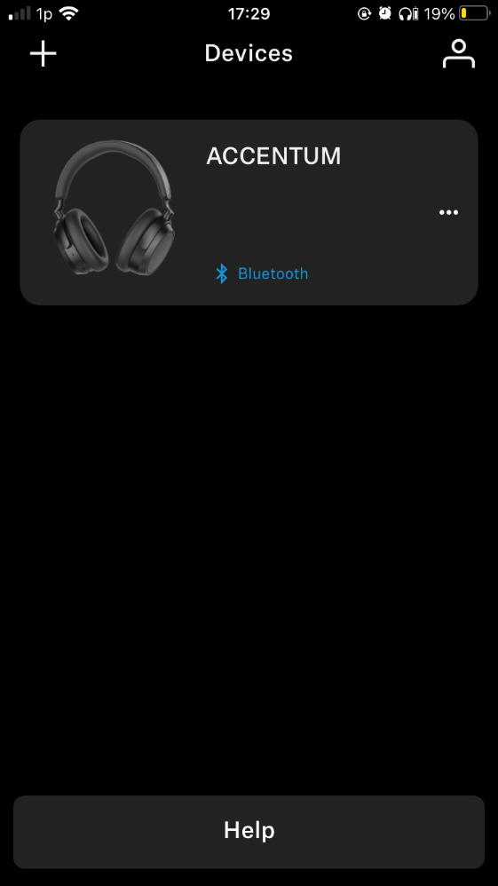

User goal:

Access the options for the headphone device.

minimalist design which minimizes clutter (positive)

Ambiguous how to select device (negative)

Screenshot Context:

On opening the app, the user to taken to the landing page that displays all the connected compatible, official Sennheiser devices. From this list the user is able to select the device they would like to access the options of. In this case, just one pair of headphones are shown.

Unclear device status (negative)

Cognitive Walkthrough Questions

1. Will the user try to achieve the right effect?

Yes

The user must select a Bluetooth device in order to view its settings. Because the prominent "Bluetooth" label makes it clear what functionality is related to device connectivity, the user is likely to select this as the proper starting point.

2. Will the user notice that the correct action is available?

Partially

Despite being a selectable option in the screenshot, "Bluetooth" lacks any visual cues (such an arrow or a "settings" icon) that would indicate selecting a device when clicked. Users used to Bluetooth menus could presume this, while others might be apprehensive.

3. Will the user associate the correct action with the effect they are trying to achieve?

Yes

Since "Bluetooth" is standard terminology for device communication, most users would associate touching it with choosing or managing devices. The typical user would assume that touching on the device of their choice will reveal the device's settings.

4. If the correct action is performed, will the user see that progress is being made toward their goal?

Yes

The user will be redirected to a page of the settings of the selected the device (next step). This would undoubtedly let the user know they have achieved their goal. As well as this, in the settings page the name of the device as well as an image of the model is shown at the top of the screen to confirm to the user the correct device has been selected.

|  |  |  |  |  |
| --- | --- | --- | --- | --- |
| **Issue** | **Description** | **Severity** | **Heuristic Violated** | **Suggested Improvement** |
| **Uncertainty in the action target** | There are no visible indications (such as an arrow) on the device label to indicate interactivity. | Medium | Visibility of System Status | Include a subtext (such as "Tap to select device") or a chevron (">"). |
| **Unclear device status** | While connected, there is a notification of the connection status ("Bluetooth"). There is just no text when the device is disconnected.  See screenshot below | High | Visibility of System Status | Include a status icon or text (such as "Disconnected" or "Connected to iPhone"). |
| **No option to search or filter** | Only two or three devices can be viewed at once without scrolling due to the extremely huge amount of space allotted for each device. Users may find it difficult to locate their desired device if numerous devices are coupled. | Medium | Flexibility & Efficiency | Add custom sorting or a search bar. |
| **"Help" option not defined** | The word "help" is ambiguous; consumers will not be able to tell if it refers to Bluetooth or general app problems. | Low | Help & Documentation | Provide context (such as "Bluetooth Help" or a small description) to make things clear. |
| **Absence of mistake prevention** | Inadvertent tapping on "Bluetooth" may cause undesirable events, such as disconnecting. | Medium | Error Prevention | For important activities (like "Disconnect this device?"), provide a confirmation dialog. |

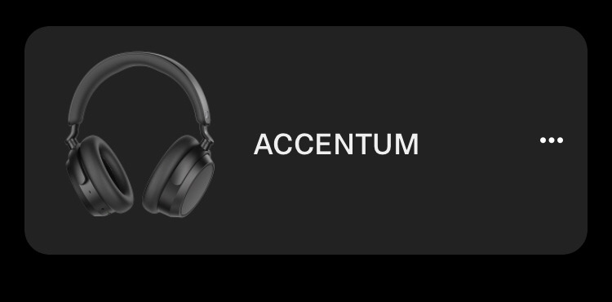

This is what the device looks like disconnected

|  |  |
| --- | --- |
| **Positive Observation** | **Heuristic Followed** |
| The main actions are the emphasis of minimalist design, which also minimizes clutter. | **Aesthetic & Minimalist Design** |
| The Bluetooth choice is immediately visible without any buried menus, though the label text could be improved. | **Visibility of System Status** |
| Users with different levels of tech expertise can be accommodated by the straightforward, text-based interface. | **Flexibility & Efficiency of Use** |
| Device names and visual icons/images provide clear identification. | **Recognition Rather Than Recall** |

|  |  |  |
| --- | --- | --- |
| Evaluation Point | Rating | Notes |
| Right effect understood | Yes | All devices are shown to the user in an organised grid. |
| Correct action visible | Partially | |  | | --- | |  |   Most users would assume that the list of devices are options to select and tapping on one selects it due to other instances of similar applications. However, less technologically literate users would not have this assumption.   |  | | --- | |  | |
| Correct mapping | Yes | |  | | --- | |  |   N/A |
| Feedback provided | Yes | |  | | --- | |  |   Taken to device management page. |

Summary of Step 1

#### Cognitive Walkthrough: Step 2 – Finding the ANC section

Screenshot Context:

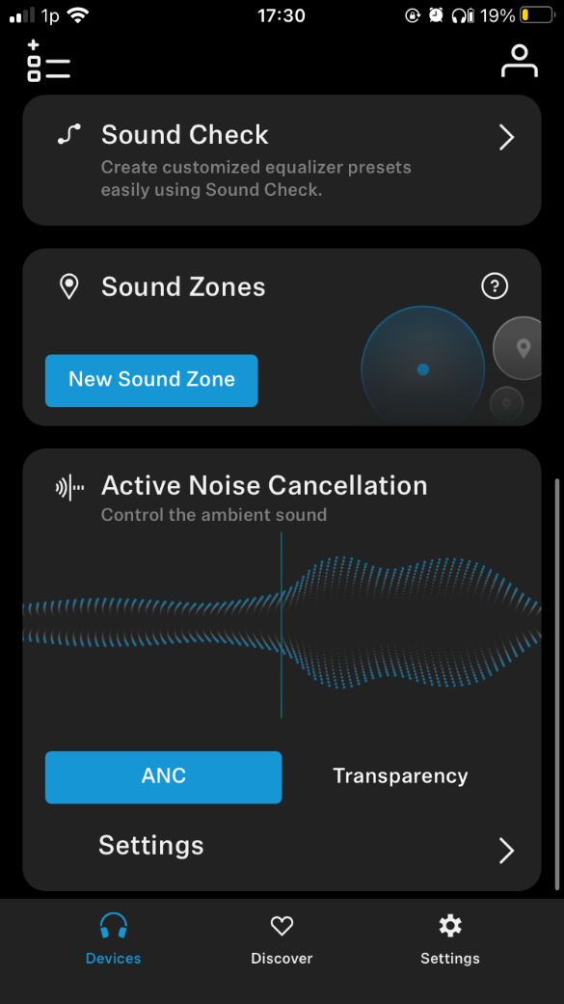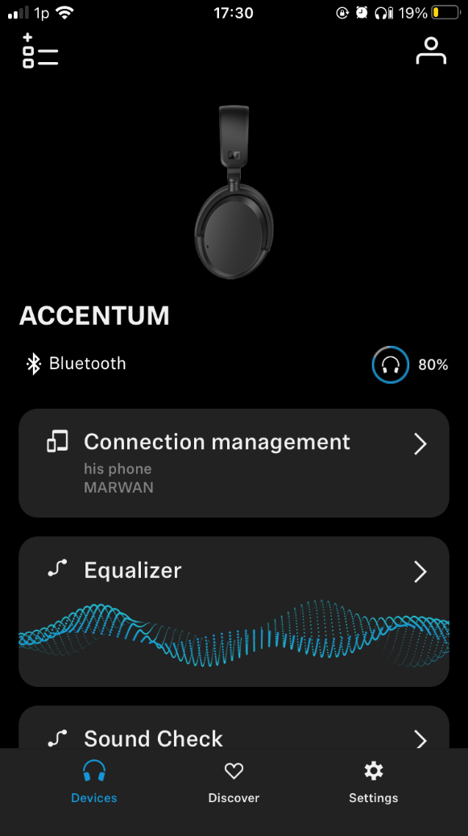

After selecting the device, the user would like to make changes to, they are brought to a page showing all the relevant information including what devices are currently connected, battery life and name of the device. Options for what can be done are also shown such as equalizer, sound zones and ANC.

Name and Image of product (positive)

User Goal:

Find the section to enable ANC.

Grid structure to section each option (positive)

Cognitive Walkthrough Questions

1. Will the user try to achieve the right effect?

Yes

‘Active Noise Cancellation’ label is very clear is what the option does and uses a very readable font and text size.

Order seems random, most frequently used sections should be near the top (negative)

2. Will the user notice that the correct action is available?

Mostly

While the options are sectioned very well, ANC is a commonly used feature and was placed at the bottom of the options. This meant it required scrolling to find. This isn’t a huge hindrance, but the most frequency visited features should be given the most spotlight.

3. Will the user associate the correct action with the effect they are trying to achieve?

Yes

Active Noise Cancellation label fits real world terms. There can be no doubt this section is for enabling ANC.

4. If the correct action is performed, will the user see that progress is being made toward their goal?

Yes

They find the section and are presented with options, they are sure this is the correct section as the label confirms it.

|  |  |  |  |
| --- | --- | --- | --- |
| **Positive observation** | **Description** | **Heuristic Followed** | **Example/Evidence** |
| Clear Hierarchy | Parts that are well-structured, featuring bolded titles and indented sub-options. | **Consistency & Standards** | Connection, equalizer, and noise cancelling are distinctly separated. |
| User-Friendly Feature Descriptions | Features such as Sound Check provide concise descriptions of their functions. | **Help & Documentation** | "Create customized equalizer presets easily using Sound Check." Description for sound check. |
| Visibility of Status | The state of the Bluetooth connection is clearly visible. | **Visibility of System Status** | Shows "his phone" and "MARWAN" (though naming could be improved). |
| Minimalist Design | Keeps things simple and concentrates on the most important controls. | **Aesthetic & Minimalist Design** | Simple design with no extraneous buttons or distractions. |

|  |  |  |  |  |
| --- | --- | --- | --- | --- |
| **Issue** | **Description** | **Severity** | **Heuristic Violated** | **Suggested Improvement** |
| Ambiguous device label | "his phone" is ambiguous; the name of the linked device should be displayed instead. | Medium | Match Between System & Real World | Change it to something dynamic, such "Connected to [Your iPhone]". |
| Undefined "Sound Zones" | There are no instructions or explanations in the feature name. | Medium | Help & Documentation | Include a subtext or tooltip (such as "Save location-based sound profiles"). |
| Low feature discoverability | "New Sound Zone" and other interactive aspects are devoid of visual affordances. | Medium | User Control & Freedom | Design as buttons ("Create New" action text with the same blue colour as the other buttons, for example). |
| Suboptimal feature ordering | Active Noise Cancelling, or ANC, shows behind less-used areas, requiring needless scrolling.  Fifth on the list, behind Sound Check/Zones, is ANC. | High | Flexibility & Efficiency of Use | Reorder sections by usage frequency: 1. Connections 2. ANC/transparency 3. Equalizer 4. Sound Zones 5. Sound Check |

Summary for step 2:

|  |  |  |
| --- | --- | --- |
| Evaluation Point | Rating | Notes |
| Right effect understood | Yes | The user is presently with several options, typically this would be a lot of information to sort through, but the formatting and organisation is so great that it is simple to find what you are looking for. If their goal is to find the ANC section, they will know it is within this area. |
| Correct action visible | Mostly | |  | | --- | |  |  |  | | --- | |  |   The option is buried and given no visual priority however clear labels mean finding it was simple. |
| Correct mapping | Yes | |  | | --- | |  |  |  | | --- | | Title text is clear as well as simple yet informative description. | |
| Feedback provided | Yes | |  | | --- | |  |  |  | | --- | |  |   N/A |

#### Cognitive Walkthrough: Step 3 – Enabling ANC

Simple organised minimalist design (positive)

No border to suggest it’s a button (negative)

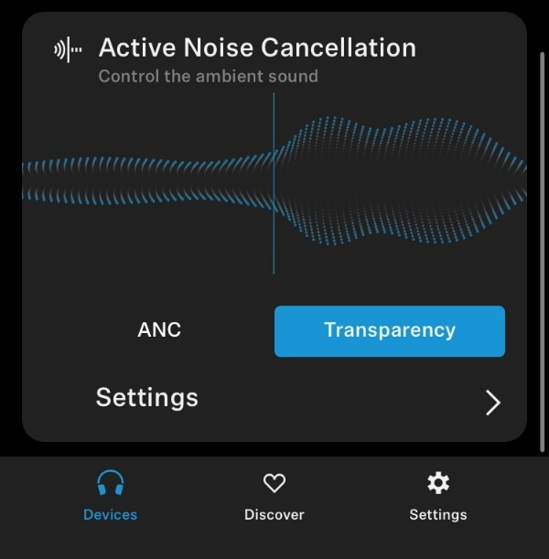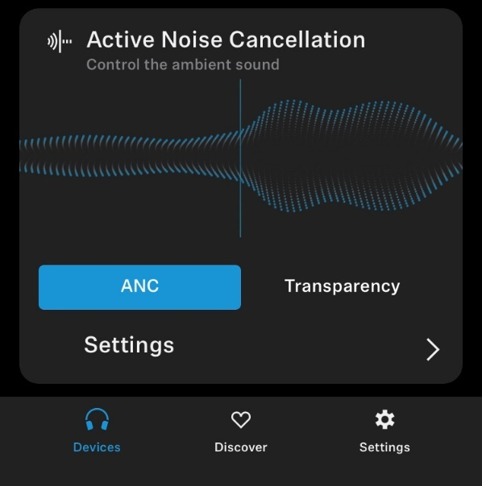

Ambiguous description (negative)

ANC On

ANC Off

User goal:

Now that the section for the ‘active noise cancellation’ has been found within the settings. The user would like to finally enable the ANC on their headphones

Screenshot Context:

The screenshots are of the ANC section in the headphones settings page. There are two screenshots one for the ANC being off, which is called transparency mode, and the other ANC being turned on.

Cognitive Walkthrough Questions

1. Will the user try to achieve the right effect?

Yes

The goal of the function is stated explicitly in the label "Active Noise Cancellation," and it is further reinforced by the subtext "Control the ambient sound."

2. Will the user notice that the correct action is available?

No

There are two options shown to the user ‘ANC’ and ‘Transparency’. The issues arises when the options are not made clear to the user that they are pressable options. There really should be a border around the labels to suggest these are tappable.

3. Will the user associate the correct action with the effect they are trying to achieve?

Mostly

For most users selecting ‘ANC’ suggests that it enables active noise cancelling. However, ‘ANC’ and ‘Transparency’ are very vague, it is not made obvious that these two are different modes, ‘transparency’ does not explicitly suggest that this is how to turn off the ANC. There should be the word ‘mode’ added to the names to further make clear these are togglable options.

4. If the correct action is performed, will the user see that progress is being made toward their goal?

Yes

The ‘ANC’ button will turned blue suggesting that this mode has been selected. As well as this, a voice is played though the headphones stating ‘ Active noise cancelling mode selected’. Even without the headphones on your head, this should be enough to confirm ANC has been turned on.

|  |  |  |  |  |
| --- | --- | --- | --- | --- |
| **Issue** | **Description** | **Severity** | **Heuristic Violated** | **Suggested Improvement** |
| **Unclear whether buttons are pressable** | It is not obvious the two options are different togglable modes (ANC/Transparency) | High | Match Between System & Real Life | Add a border around the ‘ANC’ and ‘Transparency’ labels. |
| **Ambiguous action cues/ description** | "Control the ambient sound" is a static text that does not suggest interaction. | Medium | User Control & Freedom | Replace with language that can be done something (like "Select listening mode"). |
| **Lack of customization** | No way to change the ANC's mode or strength (strong/light cancellation, for example). | Medium | Flexibility & Efficiency | In the advanced settings, add preset modes or an ANC intensity slider. |
| **Missing quick tutorial** | It is possible that novice users will not comprehend ANC functionality. | Low | Help & Documentation | Include a "?" icon with an onboarding tooltip or a quick explanation. |
| **Battery impact not shown** | Unaware users may experience a decrease in battery life. | Low | Help & Documentation | When ANC is enabled, display the battery impact indication. |

|  |  |
| --- | --- |
| **Positive Observation** | **Heuristic Followed** |
| The feature's goal is made clear by the term ("Active Noise Cancellation"). | **Match Between System & Real World** |
| Action success is confirmed by auditory feedback (sound when ANC toggles). | **Visibility of System Status** |
| A minimalist design keeps consumers from being overloaded. | **Aesthetic & Minimalist Design** |
| One Click to toggle desired mode. | **Flexibility & Efficiency of Use** |

Summary of Step 3:

|  |  |  |
| --- | --- | --- |
| Evaluation Point | Rating | Notes |
| Right effect understood | Yes | Section title is very clear. |
| Correct action visible | No | |  | | --- | |  |  |  | | --- | |  |   Not obviously buttons. |
| Correct mapping | Mostly | Ambiguous mode names. |
| Feedback provided | Yes | |  | | --- | |  |  |  | | --- | |  |   Audio confirmation provided. |

### A student downloading a selected module’s timetable for the next week

User goal:

Through the University of Hull’s student Hubble portal, the user would like to download the timetable for next week of a given module (UI/UX in this case).

**Assumptions:**

* The user is a valid student and is successful logged in.
* The student starts at the [Hull Student Portal](https://hull.service-now.com/student).
* The student is enrolled in the module the they are is looking for.
* The student is attempting this during an active school year, where lectures are currently planned and being taught (Excluding winter & easter break).

#### Cognitive Walkthrough: Step 1 – Landing page (again)

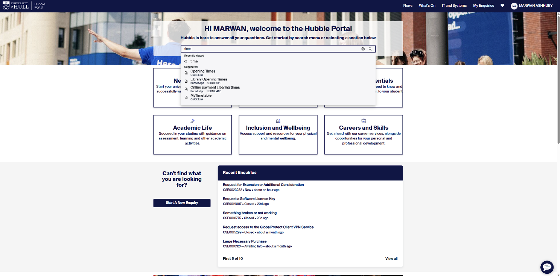

Suggestions are very sensitive, searching just table does not suggest timetable (negative)

Search bar for easy navigation (positive)

Search bar positioned front and centre in the most important section (positive)

Search bar provides suggestions (positive)

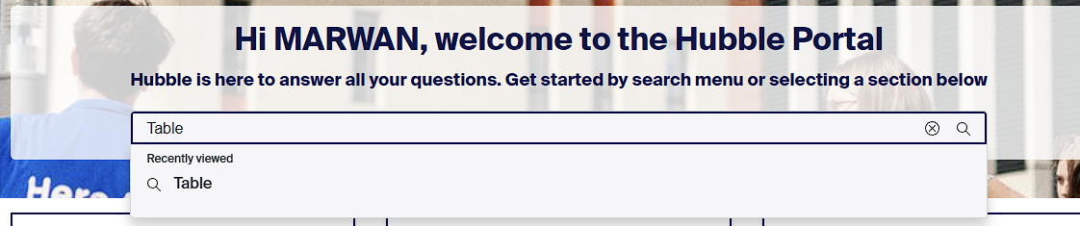

User goal:

Navigate to the timetable page successfully using the search bar (& suggested links).

Screenshot Context:

The screenshot above shows the landing page of the UOH Hubble page. This page has been covered above so points that have been already made will not be treaded. There is a search bar in the top centre of the page, which has been used to search the keyword ‘Time’ to find the page for the timetable.

Cognitive Walkthrough Questions

1. Will the user try to achieve the right effect?

Yes

The header prompts action *"Get started by search menu..."*, this makes it very obvious to the user the options available to find the section they are looking for.

2. Will the user notice that the correct action is available?

Mostly

Suggested links show up based on the keyword entered by the user. This keyword is not cap sensitive and it very useful for finding the section they are looking for. However, in this case entering ‘Table’ does not reveal suggestions for the student time table unfortunately. This may cause some users to not find the section they searched for.

3. Will the user associate the correct action with the effect they are trying to achieve?

Yes

As seen below a text cursor appears while typing letting the user know they are free to enter the keyword, which most users will recognise how to use. Once searched, suggestions will be shown, where hopefully their desired section is shown to the user. On hovering, the suggestion turns green indicating that it is clickable. This clearly shows the user this option is free to pursue. Also the naming conventions of the suggestions are very clear, all users will infer ‘mytimetable’ suggests it is that students time table.





4. If the correct action is performed, will the user see that progress is being made toward their goal?

Yes

Upon clicking a link, the user is redirected to the page of their choosing. In this example, they are taken to the ‘MyTimeTable’ page, signifying the achievement of their goal in this step.

|  |  |  |  |  |
| --- | --- | --- | --- | --- |
| **issue** | **Description** | **Severity** | **Heuristic Violated** | **Suggested Improvement** |
| **Incomplete keyword matching & Limited search scope** | "Timetable" is not suggested when "Table" is searched. Users are forced to understand precise terms as a result. If the desired results are not found, users may give up on their search. | High | Flexibility & Efficiency | Add typo tolerance, partial word matching, and synonym mapping (for example, "Table" -> "Timetable"). |
| **No loading feedback** | There is no visual cue (such as a spinner) when the page changes after clicking. Because they believe the action failed, consumers may click again as a result. | Medium | Visibility of System Status | Include a "Redirecting..." or progress spinner message. |
| **No commonly Searched section** | The absence of a section dedicated to the most frequently sought pages may result in more repetitive typing effort. | Low | Recognition Rather Than Recall | "Commonly Searched" should be shown beneath the search bar. |
| **Mobile responsiveness** | The search user interface might not work properly on smaller displays. Users of mobile devices may have trouble with accuracy. | Low | Consistency & Standards | Test and adjust for tap targets on mobile devices (minimum 48x48 pixels). |

|  |  |
| --- | --- |
| **Positive Observation** | **Heuristic Followed** |
| Users can start searching right away with a clear search initiation prompt. | Match Between System & Real World |
| For users who mix capitalization (e.g., "Timetable" vs. "timetable"), case-insensitive search minimizes errors. | Flexibility & Efficiency of Use |
| Clickable suggestions are shown by interactive hover states (green highlight). | Visibility of System Status |
| Labels for descriptive results (like "MyTimetable") indicate that consumers are able to identify options without further explanation. | Recognition Rather Than Recall |
| Quick page changes that keep the user moving forward after making a choice. | Aesthetic & Minimalist Design |

#### Cognitive Walkthrough: Step 2 – Inside the student time table

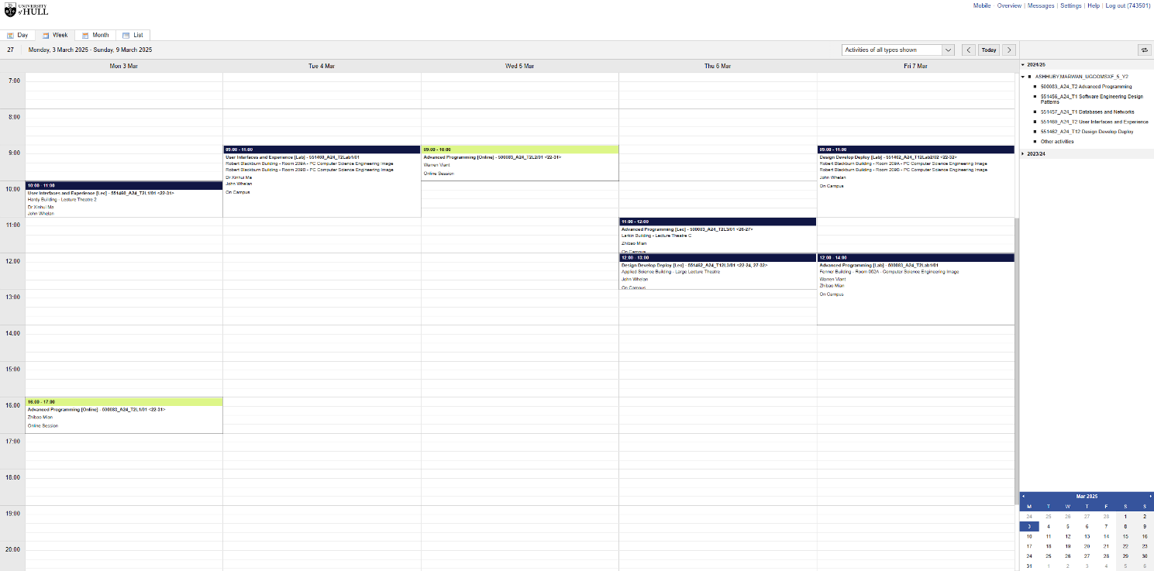

No quick link option to download timetable from this page (negative)

Organised options with same font, colour and text size (positive)

Extremely hidden option (negative)

Vague link name, overview does not suggest it is the location to download timetables (negative)



User Goal:

Find the page to download the module’s time table for next week.

Screenshot Context:

After searching for timetable in the Hubble main page and clicking on the relevant link. The user is redirected to the ‘MyTimeTable’ page. The page’s focal point is a calendar showing the lectures the student has in that given work week. To find the option to download module time tables is hidden within the ‘overview’ link at the top right of the page.

Cognitive Walkthrough Questions

1. Will the user try to achieve the right effect?

No

The link to find the option to download the time table is hidden behind the ‘overview’ link. The link itself is hidden at the top right of the screen. A separate "Timetables" or "Academics" tab may be expected by users.

2. Will the user notice that the correct action is available?

No

The "Overview" description is ambiguous; it makes no mention of a schedule or visual indicators of buried content, such as an icon or dropdown arrow.

3. Will the user associate the correct action with the effect they are trying to achieve?

No

Users will not associate "Overview" with downloads because it usually refers to a summary dashboard rather than actionable resources like timetables, which is against the Match Between System & Real World.

4. If the correct action is performed, will the user see that progress is being made toward their goal?

Yes

They will be taken to the next page.

|  |  |  |  |  |
| --- | --- | --- | --- | --- |
| **Issue** | **Description** | **Severity** | **Heuristic Violated** | **Suggested Improvement** |
| **Hidden critical feature** | Users waste time looking for the schedule download because it is hidden under the ambiguous "Overview" name. | Very High | **Visibility of System Status** | Subdivide into smaller options such as "Academics". |
| **No visual hierarchy** | Every navigation tab is equally noticeable and shows no sign of priority. | Medium | **Aesthetic & Minimalist Design** | Highlight academic-related tabs with icons/colours |
| **No quick ‘Download Week’ options** | Since downloading a schedule is a very typical demand, there ought to be a shortcut. | High | **Flexibility & Efficiency** | Add Download week button in clear view. |
| **No keyboard navigation** | Some users may not be able to access functions without a mouse or touchpad. | Low | **Accessibility** | Implement keyboard shortcuts |

|  |  |
| --- | --- |
| **Positive Observation** | **Heuristic Followed** |
| The logout option in a prominent place | **User Control & Freedom** |
| To navigate to a mobile-friendly website, use the "Mobile" link | **Accessibility** |
| Minimalist design keeps consumers from becoming overloaded | **Aesthetic & Minimalist Design** |

#### A screenshot of a computer AI-generated content may be incorrect.Cognitive Walkthrough: Step 3 – Searching for the module and downloading the timetable

Shows plenty of options at once (positive)

Can increase/ decrease amount of entries viewed at once (positive)

Export option is slightly hidden (negative)

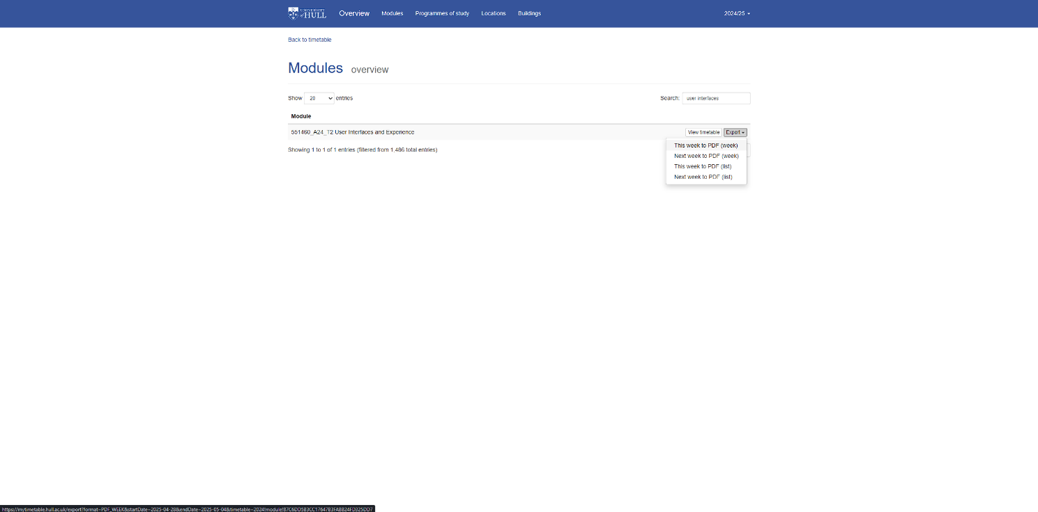

Search bar to filter modules (positive)

User Goals:

The final step entails searching for the module using the search bar and downloading the timetable for that module.

Screenshot Context:

Upon being redirected to this page from the overview link, the user is presented with all the modules available at the university. There is a search bar at the focal point of the page, which was used to search for the module ‘User Interfaces and Expirence’. At the right side of the module option there is a dropdown menu with options to download the timetable from either this week or next week.

Cognitive Walkthrough Questions

1. Will the user try to achieve the right effect?

Yes

Users accustomed to digital interfaces will automatically use the search bar, which is the main tool for finding modules. Moreover, the search bar is at the focal point (natural eye-catching position) and ‘All modules’ title sets clear expectations of what is going to be shown to the user.

2. Will the user notice that the correct action is available?

Mostly

The ordinary user will see and be able to use the search bar immediately because it is visible (high affordance). However, due to its distance from the main area of interaction, the dropdown menu on the right may be missed (Fitts's Law).

3. Will the user associate the correct action with the effect they are trying to achieve?

Yes

"User Interfaces and Experience" exactly matches the target and the dropdown label clearly suggests it houses the option to download the timetable, ‘Export’.

4. If the correct action is performed, will the user see that progress is being made toward their goal?

Yes

SEE BELOW

Upon selecting the option to ‘Export’ -> ‘Next week as PDF’, the web explorer shows a download has started. The name of the download is ‘timetable_DATE.PDF’, this confirms it is the timetable, it is the correct date and that it is in the correct format.

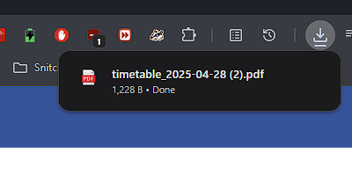

Download confirmed

Here is the download

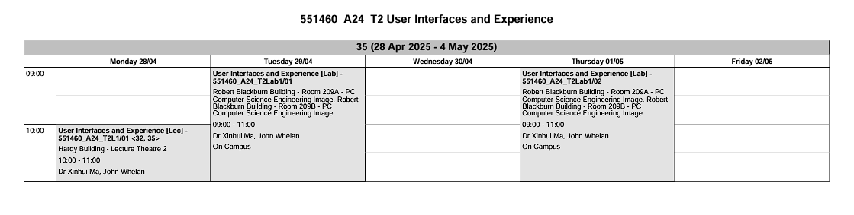

|  |  |  |  |  |
| --- | --- | --- | --- | --- |
| **Issue** | **Description** | **Severity** | **Heuristic Violated** | **Suggested Improvement** |
| **Dropdown placement violates Fitts's Law** | The main interaction area (module title/search) is far from the schedule download menu. | Medium | Flexibility & Efficiency | Add a dedicated button or move the download option next to the module name. |
| **Generic export label ("Export")** | Does not specifically mention the ability to download schedules. | Low | Match Between System & Real World | Put "Download Timetable" as the label or include a calendar symbol (📅). |
| **Basic filename convention** | The module-specific context in "timetable_DATE.PDF" is absent. | Low | Recognition Rather Than Recall | Add the module name or code (for example, "UIX_Timetable_2023-11-20.pdf"). |
| **No multi-export option** | For several weeks, users have to repeat the procedure. | Medium | Flexibility & Efficiency | Include a "Download all weeks" option that may be downloaded in ZIP format. |

|  |  |
| --- | --- |
| **Positive Observation** | **Heuristic Followed** |
| The search bar is positioned in the centre for easy viewing. | Visibility of System Status |
| "All modules" title sets accurate expectations | Match Between System & Real World |
| The module name ("User Interfaces and Experience") matches exactly. | Recognition Rather Than Recall |
| Verified download ("timetable_DATE.PDF") | User Control & Freedom |
| Options for exporting by week ("Next week as PDF") | Flexibility & Efficiency of Use |
| Standardized PDF format for timetables | Consistency & Standards |

## Part 2 – Iterative Prototype design

For the second part of this report, two specified interaction case studies designs will be created. The process will be documented from the low fidelity mock ups drawn up on paper to the higher fidelity designs created with ‘Figma’ with some interactivity show casing.

### Prototype One – Personal supervisor system mobile application ‘PersonallySupervised’

The first case study specified was a ‘Personal supervisor system’ from a previous module. The general idea is that “students should be more easily able to interact with their personal supervisor”.

Early in the researching and concept phase, it was decided the form the prototype would take is that of a mobile application. This is because in thinking in how to maximise accessibility and ease of use, the mobile phone became the obvious choice. This would show to have its own unique set of problems in development as opposed to a desktop website, but undoubtedly the best choice.

There was a set of use cases the application must include and goals it must adhere to. It is important to note that this application is made to be used by students only. Use cases explore the tasks the application should be able to accomplish, while the goals are broader, more generally rules.

Use Cases:

* A student must be able to self-report how they are feeling.
* A student must be able to book a meeting with their personal supervisor.

Goals:

* Ease the process of booking a meeting, while simultaneously exposing the student to all the options they may need.
* Give the student quick and easy access to essential information.

Before designing a single element, I conducted some research into mobile application user interface design and how user experience is optimised. This may be referenced throughout the design overview.

#### Very low fidelity - First Design

The first design was an extremely rough draft on pen and paper. The advantage of low fidelity prototyping occurred to me here as this was able to be drawn in less than a minute. Despite the low effort and time investment, this design was helpful in mapping out the key features.

It features all the use cases that must be implemented set in an organised grid structure with borders sectioning off the options, making it entirely clear that these options are separate. Moreover, there is a hierarchy to the option ordering, with the most important section at the top and the processing sections ranked on the same factor.

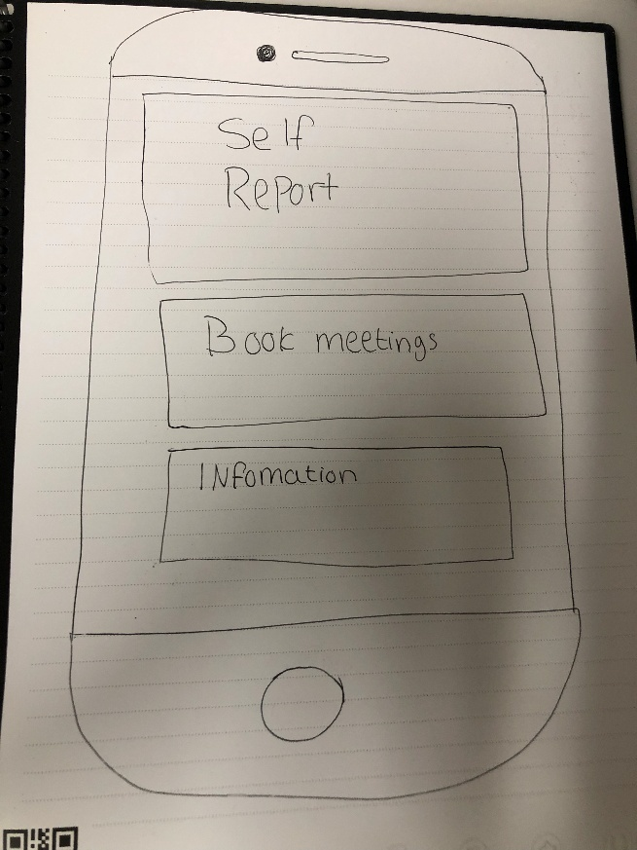

Grid structure.

All information fits on screen at once.

Hierarchy of importance.

#### Low fidelity – Basic functionality and information architecture

After analysing the previous draft, it was realised that one page would not be enough to house all the options and information a student requires.

The prototype now distributes features across four pages to reduce cognitive load. For example, the homepage prioritizes quick access to the self-report system and supervisor info, while a dedicated booking page simplifies scheduling (user goal).

Upon loading the application, the user will be taken to the home page.

##### Homepage

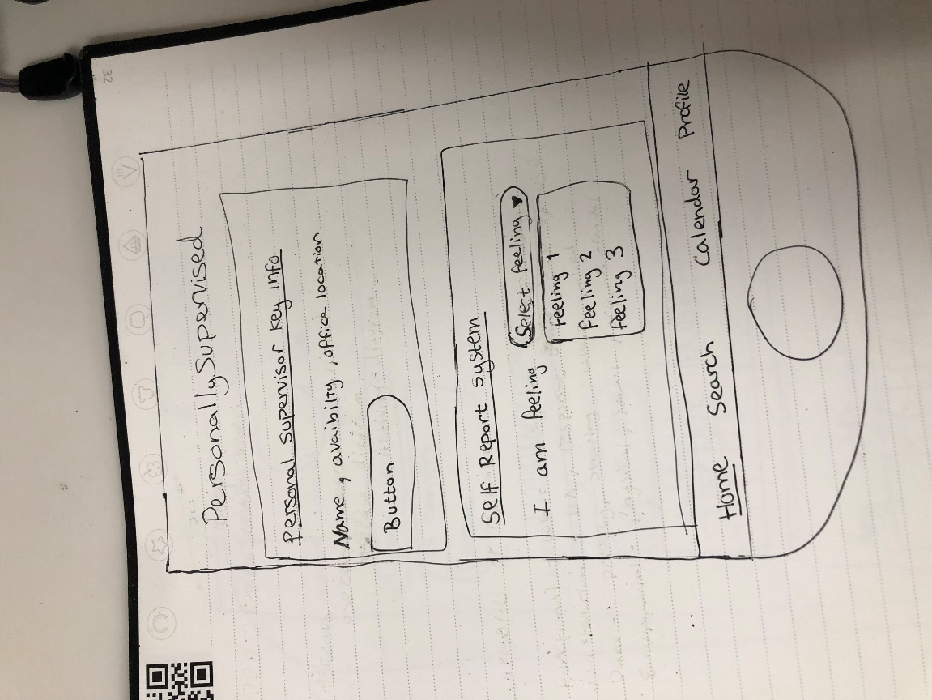As this page is the first thing the user will see and be able to interact with, the most important/ frequently used sections should be here.

Key information about the students PS is shown.

This button takes the user to the ‘book meeting’ section.

Drop down with all valid options.

Bottom navigation bar added, where the current page is underlined.

This is the application's home screen. There are two main parts to it:

1. Important details regarding the student's designated supervisor, such as name, availability, and office address, are displayed in the Personal Supervisor Key Info Panel. A button is in clear view, which redirects the user to the ‘book meeting’ page.
2. Self-Report System: Students can choose how they are feeling right now using a drop-down menu (e.g., “Feeling 1,” “Feeling 2,” etc.). This encourages frequent self-check-ins from students and may be connected to staff alerts or wellbeing monitoring.

The app's objective of assisting with monitoring and student welfare is reinforced by the fact that both portions are made to be easily accessible and interactive. To make it simple to navigate between important areas, the navigation bar stays at the bottom.

**Relevant Heuristics & UX Guidelines**

1. **Match Between System and the Real World**  
   Demonstrates intuitive mood selection (Feeling 1, Feeling 2 etc.) and the use of straightforward language such as "I am feeling..." encourages emotional tone and organic engagement.
2. **Flexibility and Efficiency of Use**  
   Quick and easy mood reporting is made possible with a dropdown menu. Perfect for rapid, frequent updates.
3. **Help Users Recognize, Diagnose, and Recover from Errors**  
   Invalid mood input is prevented using dropdown input. Error avoidance and selection simplicity.
4. **Visibility of System Status**  
   The present status and accessible options (such as the supervisor details and the mood picked) are plainly visible to the user. guarantees faith and confidence in the system's operation.
5. **Aesthetic and Minimalist Design**  
   There are separate areas for supervisor information and welfare input, and the structure is simple. promotes comfort and concentration.

##### Book meeting

Students can arrange a meeting with their personal supervisor using this screen. Users are prompted to choose the location of the meeting in the top portion, which provides a drop-down menu with the choices "on campus" and "online." Below this, the user can select a time slot (such as 9:30 AM) from a time selector and a date (such as June 10, 2024) using a visual day picker.

Students can provide further details or context to the meeting request by using a text box. To complete the meeting, the user can click the "Submit booking request" button after completing the form. The Home, Search, Calendar, and Profile pages are easily accessible thanks to the dependable bottom navigation bar.

All necessary information for making a reservation is centralized on this screen, which keeps the form brief and user-friendly.

Simple language

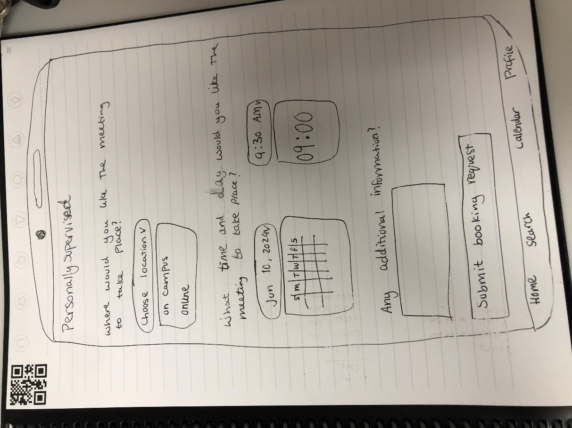

Questions asked one at a time to separate meeting values.

Drop down to show all allowed options.

Date/Time uses the phones built in dropdown, this means users will already know how to use them (e.g. apple and android software differ).

**Relevant Heuristics & UX Guidelines**

1. **Visibility of System Status**  
   Select values are displayed clearly via the date and time pickers (e.g., "Jun 10, 2024", "9:30 AM"). At a glance, the user is aware of what they have chosen.
2. **User Control and Freedom**  
   Changing input is made simple via dropdown menus and buttons (e.g. changing meeting time or location) which allows for modification without beginning anew.
3. **Consistency and Standards**  
   Makes use of standard user interface elements such as calendar pickers, dropdown menus, submit buttons, and bottom navigation, which reduces the user's learning curve.
4. **Recognition Rather Than Recall**  
   The button labels (such as "Submit booking request") and calendar layout are user-friendly. Options are displayed, so the user does not need to remember them.
5. **Aesthetic and Minimalist Design**  
   The screen is kept clear and focused by only displaying the fields that are required (location, time, and notes). lessens cognitive burden, making it perfect for people under stress.

##### Calendar

Students can view their scheduled appointments with their personal supervisor on this screen, which functions as a weekly calendar interface. A horizontal time grid (9:00–13:00) is displayed at the top of the screen, and the days of the week (Monday–Sunday) are listed on the vertical axis. Scheduled meetings are shown as blocks with labels (such as "meeting info") that correspond to the timeslots and days they are scheduled for.

Users can:

* See a visual overview of their weekly schedule and events.
* To view additional information, tap on a "meeting info" block.
* To rapidly transition between displays, use the dependable bottom navigation bar (Home, Search, Calendar, Profile).

This design emulates well-known calendar applications, facilitating rapid identification and planning.

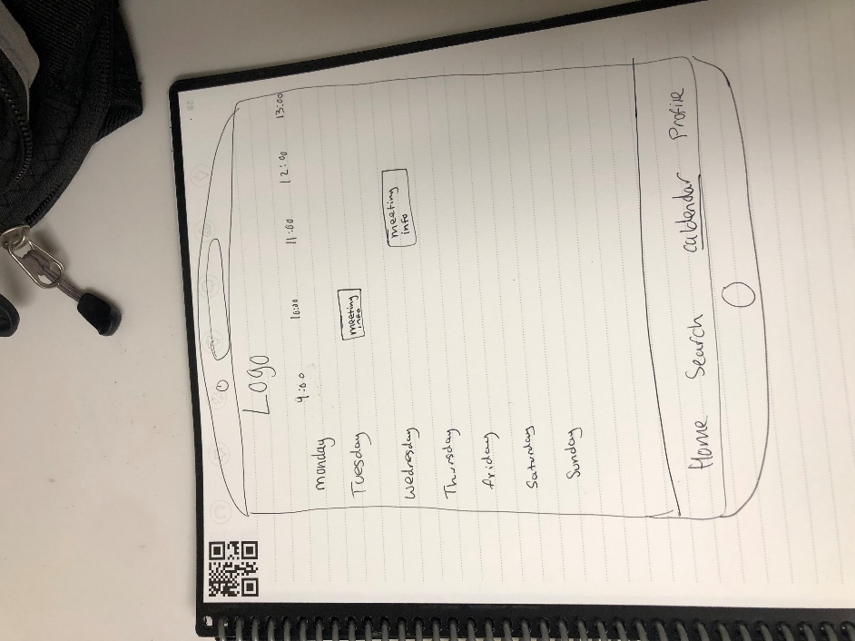

Meeting slots show key data (location etc.)

Calendar grid system makes it simple to check time of meeting.

‘Calendar’ is underlined to confirm to user which page they are on in the bottom navigation tab.

**Relevant Heuristics & UX Guidelines**

1. **Match Between System and the Real World**  
   The time slots and days of the week adhere to a traditional calendar format, meeting user expectations. The layout is immediately clear to users without any further explanation.
2. **Recognition Rather Than Recall**  
   Meetings are displayed contextually, such as Tuesday at 10:30, which lessens the memory load. Users do not have to recall times or navigate away to find information.
3. **Consistency and Standards**  
   The bottom navigation bar is repeated from earlier displays, and the design adheres to a standard calendar arrangement. guarantees the predictability and usability of the interface.
4. **Aesthetic and Minimalist Design**  
   There are no extraneous indicators or clutter—only pertinent info is shown. encourages usability and clarity, especially for mobile users.
5. **Visibility of System Status**  
   Users quickly view booked events. Additional information or input may be obtained by interacting with a "meeting info" block. Helps one quickly comprehend their weekly schedule.

##### Search

Students should also be able to view past meetings with their personal supervisor. This log should show all relevant information about that meeting; Data such as meeting number, a unique identifiable code for each meeting, the location of the meeting (on campus or online), the date of the meeting and the reason for the meeting. The reason may be the description the student gave when booking the meeting or due to a concerning submission to the weekly self check up.

While the meetings will be organised in a orderly grid like manner in a chronological ordering, students should be able to search for meetings on top of this.

Search bar for quick look up.

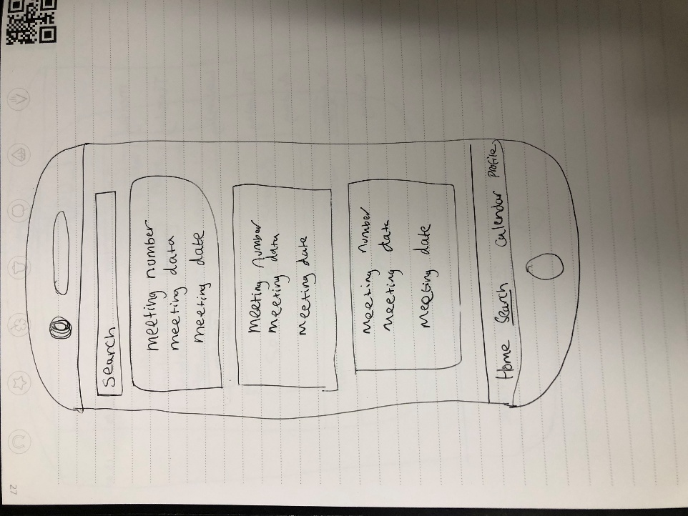

Ordered in chronological order will most recent meetings at the top.

Meeting container houses all key data on meeting.

Each meeting is properly separated.

**Relevant Heuristics & UX Guidelines**

1. **Visibility of System Status**

The presence of a search bar implies that the user will receive feedback following a search activity and that the system will react to user input visibly (e.g., by displaying filtered results).

1. **Match Between System and the Real World**

Makes use of well-known and unambiguous terms such as "Meeting Number," "Meeting Data," and "Meeting Date" to conform to users' mental models and expectations.

1. **Consistency and Standards**

In accordance with platform standards, the bottom navigation bar's layout (Home, Search, Calendar, Profile) is continuous across the application.

1. **Recognition Rather Than Recall**

Allows customers to identify the meeting they are looking for without having to remember specifics by displaying meetings in visible cards with important information.

1. **Aesthetic and Minimalist Design**

With just the essential components (search bar, meeting cards, and navigation), the layout is clear and uncomplicated, making it straightforward to scan and comprehend.

1. **Flexibility and Efficiency of Use**

Users with varying demands can benefit from the search function's ability to swiftly locate particular meetings, which supports both targeted and casual browsing.

##### Profile

This final page houses all the personal information about the user that may be relevant. This includes their name, course, student email, student number as well as who their personal supervisor may be.

As well as key information about the user, the section below it displays the status of completion of the weekly self check in system.

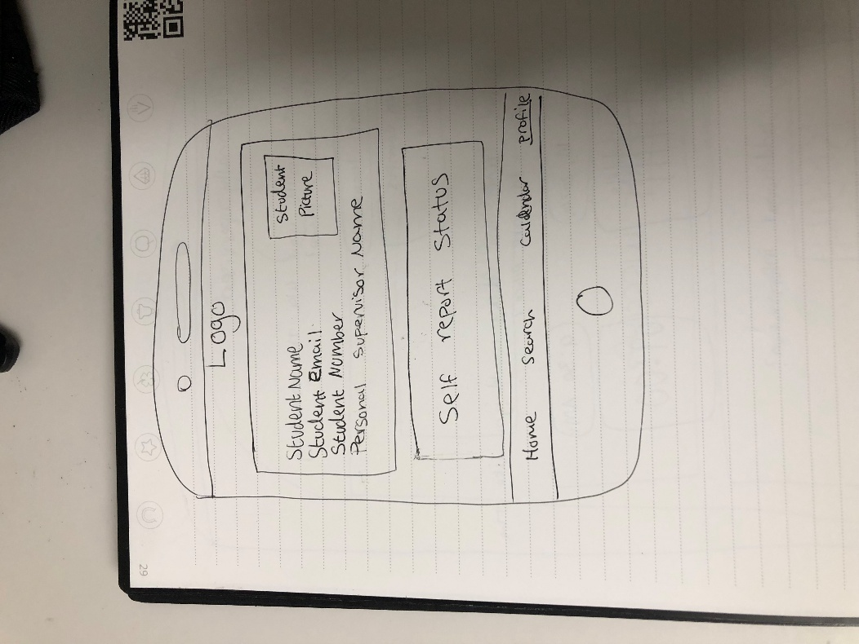

All related information is shown in the same section.

Reminder to complete self report if status is ‘incomplete’.

Current page is underlined.

**Relevant Heuristics & UX Guidelines**

1. **Visibility of System Status**

Persistent user data is displayed in student information boxes (Name, Email, Student number, and Supervisor). Without the need for manual checks, "Self report Status" serves as a clear indicator of task completion status, allowing users to view their saved details and outstanding activities promptly.

1. **User Control and Freedom**

The bottom navigation ("Home", "Search", "Calendar", and "Profile") allows users to quickly browse between sections.

1. **Consistency and Standards**

Follows a conventional form layout, which minimizes reading effort by labelling fields in a vertical order.

1. **Recognition Rather Than Recall**

Every profile field has a clear label; no information is hidden. By keeping important information visible across screens, navigation icons reduce memory strain.

1. **Aesthetic and Minimalist Design**

Only the most important information is displayed; no extraneous details. Bold labels and plain text inputs create a clear typographic hierarchy that directs attention to profile management activities.

#### High fidelity – Interactive ‘true to form’ prototype

This high-fidelity Personal Supervised prototype shows off a smartphone app intended to help students and academic supervisors communicate. A homepage with supervisor contact details and mood self-reporting, a meeting search tool, a multi-step booking system, an interactive calendar, and student profile comprise the prototype's five main displays. The design streamlines important processes like appointment booking and emotional state reporting by implementing consistent bottom navigation, a clear visual hierarchy, and limiting option inputs in accordance with Nielsen's usability guidelines. The interface maintains user control while emphasizing system state visibility through meeting confirmation alerts and incomplete task notifications.

This prototype evolved directly from the lower fidelity models, but instead of using generic placeholders (such "Feeling 1, 2, 3"), the high fidelity version incorporates data and functionality from the real environment, such as:

* Content that is dynamic: Rather than displaying fictitious text, supervisor availability displays genuine time slots.
* Contextual interactions: The booking flow now verifies submissions using notifications provided by the system and filters valid options (for example, only showing hours available for weekdays selected).
* Personalized components: The self-report system employs subtle emotional words ("Great/Lost/Stressed") in place of numbered placeholders, and the profile page has unique student data (such as "Timmy Wotkins, Software Engineering").
* Visual polish: In accordance with platform guidelines (Material Design/iOS), wireframe boxes are replaced with consistent typography, colour coding (e.g., calendar events), and iconography.

While maintaining the original architecture, these improvements turn conceptual procedures into concrete interactions.

This prototype is where the researching of mobile application as an interactive medium played heavily in the implementation of the wireframing.

For example, unlike desktop alternatives not all parts of the interactive screen are equality as accessible as others. The space in green shows the area users will find very comfortable to navigate. For this reason, when the appropriate and available buttons or other selectable options will be placed on the right side, staying clear of the top ten percent of the screen where ease ability of use falls off.

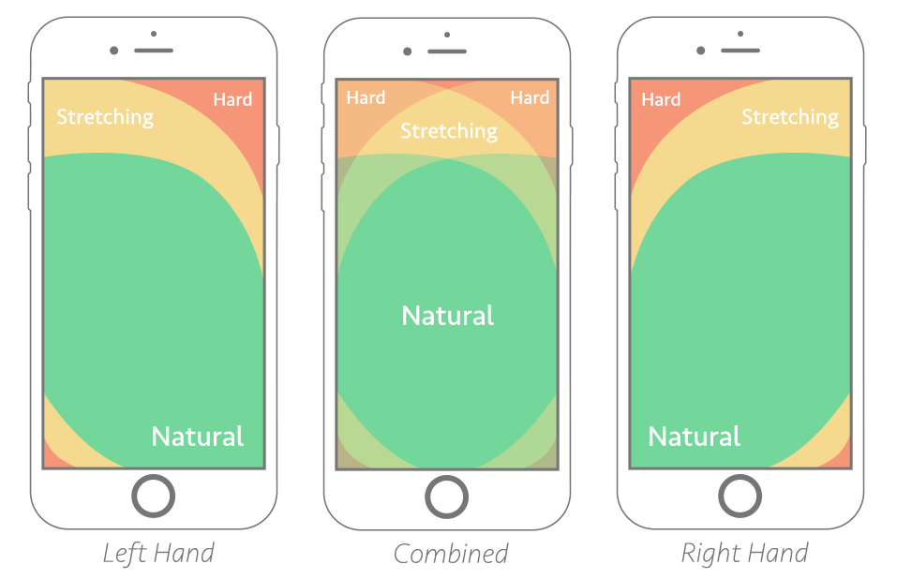

Figure 1 Accessibility graph for a touch screen

One change from the previous prototype is the is the addition of another section to the bottom navigation bar. While the ‘book meeting’ page can be accessed from the home page, the inclusion of its own tab placed front and centre shows off its importance. This provides a second way of accessing this, bound to be frequently used, tab.

The sections have also been given icons to accurately depict their use and synergise with the ‘**Match Between System and Real World’** heuristics. Instead of the text being underlined, I settled for a boldening of the text, which I found makes it much simpler to see which page is currently shown at a glace while sustaining the legibility of the title.

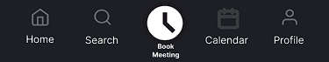

##### Home Page

A prominent "Book Meeting" call-to-action, (1) the supervisor's contact information and availability in real-world terms (e.g., "RBB-307: Mon-Fri 09:00-17:50"), and (3) an emotional self-reporting system with progress tracking ("Week 14: Incomplete") are all displayed on the homepage, which acts as the focal point for interactions between students and supervisors. This keeps the bottom bar for easy navigation while combining important functions into a single display.

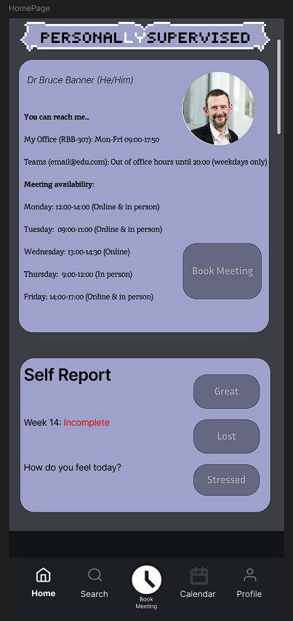

Personal supervisor data is shown in a readable way using friendly understandable language.

Standardised format:

24-hour time

Ordering (day, time, location)

Buttons are all placed in ‘golden zone’ of thumb accessibility.

Status is clear and coloured in red to show urgency.

**Relevant Heuristics & UX Guidelines**

1. **Match Between System and Real World**

Traditional calendar formatting is used for time slots (e.g., "Monday: 12:00-14:00"), and labels such as "You can reach me..." employ natural language, which mimics real-world scheduling standards and removes learning curves.

1. **Recognition Rather Than Recall**

Contextual displays of supervisor availability (e.g., "Wednesday: 13:00-14:30 (Online)") and self-report alternatives ("Great/Lost/Stressed") are consistently displayed. Users never have to search for important information or commit details to memory.

1. **Consistency and Standards**

Uses the bottom navigation bar from previous screens, as indicated by the "Home/Search" icons that have been truncated. Respects platform standards (e.g., Material Design button hierarchy, iOS tab bar spacing). guarantees consistent interactions throughout the application.

1. **Aesthetic and Minimalist Design**

Removes ornamental aspects and places more emphasis on self-reporting, booking button, and supervisor information. makes use of typographic hierarchy and lots of white space (strong headings, subdued body text). lessens cognitive burden for mobile use that is task-focused.

1. **Visibility of System Status**

The tag "Week 14: Incomplete" clearly indicates that there are still tasks to be done. By preventing out-of-date reservations, the real-time availability display keeps users updated on system status without requiring manual checks.

**Principal Advancements in Low-Fi Data Realism:**

Actionable "Book Meeting" CTA was used in place of the "Button" placeholder.

Temporal clarity: Time slots that are specific (as opposed to the general ‘availability’ in low-fi).

Emotional accuracy: "Great/Lost/Stressed" provides more detailed information than numerical choices.

This minimizes unclear inputs, which is consistent with Nielsen's error prevention heuristic.

##### Search (Interactive)

This screen allows users to search and review previous meeting records based on meeting codes or dates. At the top, a search bar enables text input for keywords or meeting IDs, and it includes a microphone icon for voice search input, added for accessibility for those users who may struggle typing. A “Cancel” option on the right lets users quickly exit the search mode.

Each meeting result is displayed as a card-style entry that shows:

* The meeting ID (e.g., #BB1052)
* The location (either online or a room number)
* A short summary or student note (reason for meeting)
* The meeting date

Users may easily find previous exchanges, consider earlier discussions, or get ready for follow-ups thanks to this design. Keeping track of support-related activities and staying organized are particularly beneficial for students.

The screen and the bottom navigation bar provide a unified interface that makes it easy to go to the Home, Book Meeting, Calendar, and Profile areas.

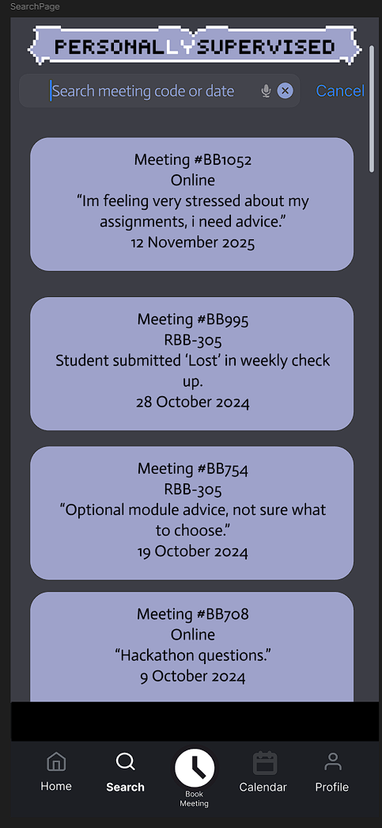

Scroll bar to more quickly scroll the list/ see what position in list currently at.

Searching can be done using either the meeting code or date of meeting.

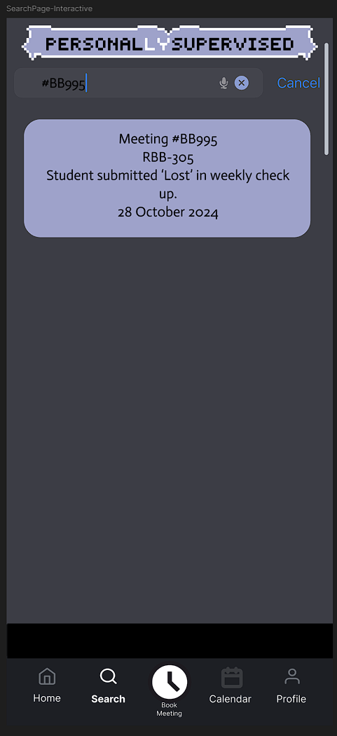

Voice input available.

Meeting cards are ordered chronologically from most recent to least.

All key meeting data is shown in a concise manner.

**Relevant Heuristics & UX Guidelines**

1. **Visibility of System Status**

The search input shows real-time suggestions. Search results immediately update in response to input.

1. **Match Between System and the Real World**

Dates and meeting IDs are formatted consistently and clearly, and the language used is natural and student-friendly (e.g., "Lost in weekly check up").

1. **User Control and Freedom**

At any moment, users can use the "Cancel" button to end the search. Voice input provides additional ways to operate the application.

1. **Consistency and Standards**

Employs the same bottom navigation and iconography as other pages (Home, Search, Calendar, etc.); To make them easier to recognize, meeting cards have the same design and format.

1. **Recognition Rather Than Recall**

Search eliminates the need to recall specifics by using accessible historical data cards. For search tasks, voice input considerably lessens cognitive stress.

1. **Aesthetic and Minimalist Design**

Strong contrast and visual hierarchy are produced by the light cards on a dark purple background. Each card displays only the most important information—no extraneous details or distractions.

1. **Flexibility and Efficiency of Use**

Allows for both speech and text input, accommodating a range of user preferences and skill levels.

1. **Help Users Recognize, Diagnose, and Recover from Errors**

A smart search improves recovery by providing suggestions or error messages in the event that no results are found.

1. **Help and Documentation**

Help documentation is not as necessary because to the user-friendly interface. The user can be guided by clear labelling, such as "Search meeting code or date."

##### Book Meeting (Interactive)

Students can use this screen to schedule a meeting with their personal supervisor by navigating a form-like interface. The procedure is broken down into simple steps:

* Users have the option to choose between "online" and "in person."
* Select a weekday: Using buttons, you can choose your preferred weekday.
* Select a time: There are predetermined time windows available, such as 12:00, 12:30, etc (which is checked against both the PS’s availability for that weekday and whether that timeslot has already been taken).
* Extra details: The user can explain the meeting's goal in a free-text input section.
* Click the "Submit" button. The reservation is completed via a big button at the bottom.

When you click Submit, a confirmation window displays:

* It attests to the request's transmission.
* The user is notified that an email notification will be sent to them.
* The meeting is immediately added to the user's calendar if the supervisor agrees.
* The popup gives you two choices: go back to the webpage or schedule another meeting.

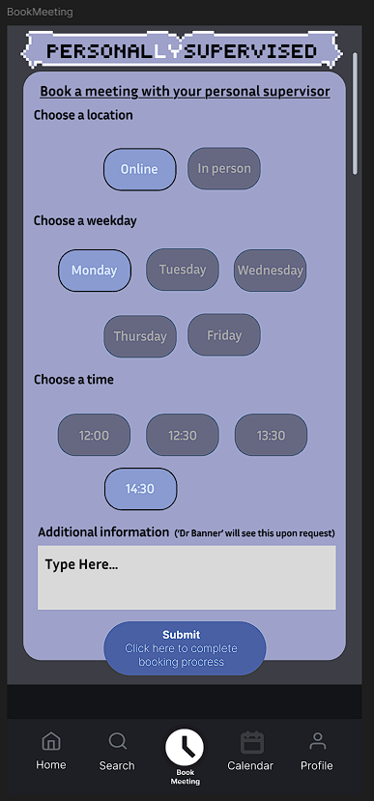

Selected option is made very clear with outline and lighter colouring.

Friendly dialogue to prompt answer.

Only times and days the personal supervisor has set as available are shown to user.

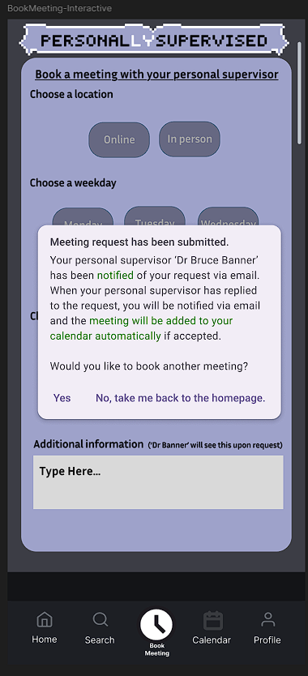

Clear language and end goal.

Additional information box as a handful of predetermined reason options may not cover all reasons.

Confirmation text is clear with key information coloured in green so the eye can find quickly.

Multiple easy to understand options are given to user.

**Relevant Heuristics & UX Guidelines**

1. **Visibility of System Status**

Following submission, users are reassured that their request has been handled by the confirmation window, which provides instant feedback.

1. **User Control and Freedom**

Users have choice over the following step after submitting, since they can decide to schedule another meeting or go to the home page.

1. **Recognition Rather Than Recall**

There is no need for manual entry because time slots, days, and locations are shown as selectable buttons.

1. **Consistency and Standards**

Visual styling and icons are used consistently throughout the bottom navigation bar (Home, Search, Book Meeting, Calendar, Profile).

1. **Error Prevention**

Users are less likely to provide incorrect information if there are only legitimate alternatives for time and day.

1. **Aesthetic and Minimalist Design**

Usability is increased and clutter is decreased by the simple layout and one activity per screen.

1. **Help Users Recognize, Diagnose, and Recover from Errors**

Confirmation text eliminates doubt or the need for user troubleshooting by providing a clear explanation of what occurs next.

##### Calendar

A monthly overview of the planned meetings for personal supervision is available on the Calendar page. Users can visually monitor past, present, and upcoming meetings with its assistance. Important characteristics include:

* + Month and Year Display: The current month and year ("March 2025") are displayed clearly.
  + Using a conventional calendar format, the monthly calendar grid shows the days of the month.
  + Indicators of Meeting: Dates are shown with boxes that show:
    - Meeting time (such as 9:30, 13:30, or 18:00)
    - Location of the meeting (online or room code, such as RBB-301)
* Meeting Count: The total number of meetings for the month is shown in the upper right corner (e.g., "3 meetings this month").
* Navigation Bar: Home, Search, Book Meeting, Calendar (highlighted), and Profile are all accessible from the standard bottom navigation bar.

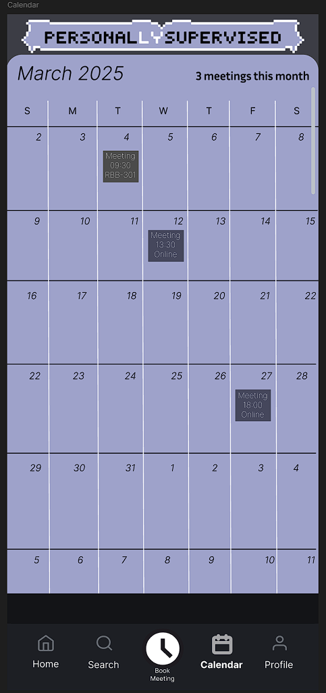

Useful key information shown front and centre.

Clear commonly used grid structure for calendar.

Scroll bar to view both past and future months.

Meeting container colour differs whether location is ‘online’ or ‘in person’ so users can check while a quick glance.

Meeting container shows only key data.

Calendar tab is bold in bottom navigation.

**Relevant Heuristics & UX Guidelines**

1. **Recognition Rather Than Recall**

Without having to remember dates, users may visually identify their schedule thanks to the calendar format.

1. **Visibility of System Status**

Transparency is maintained by letting users know right once how many meetings are scheduled and on which days.

1. **Consistency and Standards**

There is visual coherence with the rest of the application (e.g., header style, colour scheme, nav bar).

1. **Aesthetic and Minimalist Design**

Only the most important information, such as the time and place of each meeting, is displayed on the clear interface.

1. **Flexibility and Efficiency of Use**

At a glance, users may rapidly scan the month for busy times or free days.

1. **Match Between System and the Real World**

Using a conventional calendar grid is in line with user expectations and scheduling mental models in the real world.

1. **Help and Documentation** (Implicit)

The interface is self-explanatory because of its familiar style and simplicity, even if no visual help is displayed.

##### Profile

Users can view a concise summary of their personal information and current academic participation status on the Profile page. Features consist of:

* An image of the student, same used as on their student cards.
* Name Display: Provides the complete name of the user, such as Timmy Wotkins.
* Contact Details: shows the email address of the university.
* Academic Information:
  + Title of the course (Software Engineering, for example)
  + Personal supervisor assigned (e.g., Dr. Bruce Banner)
* Self-Report Status:
  + Indicates the week of study (e.g., Week 14).
  + shows the status of the self-report (for example, "Incomplete" in red).
* An interactive hyperlink ("here") that leads to the reporting page and prompts the user to finish the report.
* Bar of Navigation: The "Profile" symbol is highlighted, in keeping with the rest of the application.

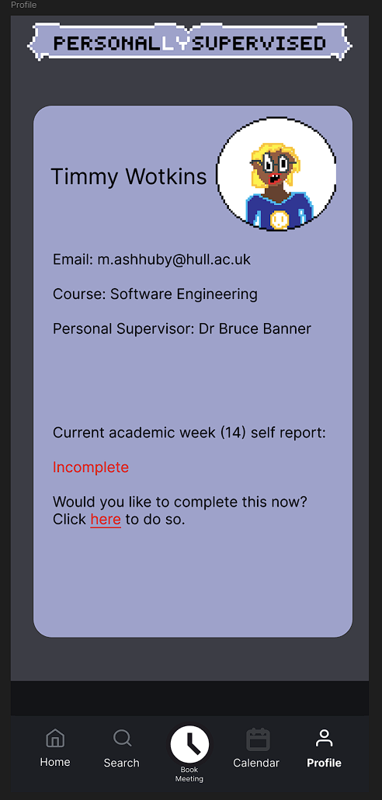

Key personal information is shown in an organised manner.

Status of self report is shown with current report of ‘incomplete’ in red text to suggest urgency.

Call to action to complete self-report if not done so already, with link to page.

**Relevant Heuristics & UX Guidelines**

1. **Visibility of System Status**

Conveys the user's self-report status in an understandable manner, which is essential data for measuring engagement.

1. **Match Between System and the Real World**

The interface makes simple use of well-known ideas like names, email addresses, academic weeks, and supervisor details.

1. **Recognition Rather Than Recall**

Users do not have to remember it or look for it elsewhere because all pertinent information is displayed on the page.

1. **Consistency and Standards**

The navigation bar, colour scheme, and design language are all the same as on other sites.

1. **Error Prevention**

Users are kept from forgetting or ignoring partial contributions by the prominent link to finish the self-report.

1. **Aesthetic and Minimalist Design**

Avoids distractions and clutter in favour of concentrating only on the information that is essential.

1. **Help Users Recognize, Diagnose, and Recover from Errors**

"Incomplete" is prominently shown in red, and a call to action (the clickable link) is included to fix it.

1. **User Control and Freedom**

Enables the user to use the offered link to act on their status voluntarily and at their own leisure.

### Prototype Two – Wireless all-in-one home lighting controller website ‘MyShine’

The creation of a high-fidelity prototype for a website that controls lights in smart homes is the main topic of this case study. In order to encourage good behavioural changes in daily energy usage and to promote energy sustainability, the system allows users to monitor and control lighting in various rooms of their home.

Following accepted user interface standards and usability heuristics like Nielsen's principles, the prototype was created with accessibility and usability in mind. Remotely turning lights on or off, checking lighting connectivity status, adding new lights to the ecosystem and choosing the colour for the LED (if compatible with light) are examples of core interactions. Simple controls, status indicators, and feedback systems guarantee that users have intuitive control over their surroundings.

From low-fidelity wireframes to a fully realised high-fidelity prototype, the website design has evolved but share the common goal of giving users control of their homes and reducing the actions needed to do so, providing a convenient solution to this problem.

#### Low fidelity

This section documents the foundational wireframes that establish the core functionality and user flows of ‘MyShine’. These simplified, monochromatic designs focus exclusively on information architecture and interaction patterns, intentionally omitting visual details to prioritize:

1. **Task Clarity** – How users accomplish key goals (e.g., submitting a contact form)
2. **Navigation Logic** – Placement of critical UI elements (buttons, menus)
3. **Content Hierarchy** – Spatial relationships between primary/secondary information

Created with placeholder text and basic shapes, these prototypes serve as a proof of concept for usability testing—allowing rapid iteration before committing to high-fidelity designs.

As with the previous prototype the wire frames and basic functionality and outline for the final products were drafted on pen and paper.

##### Register & Login

These sections make up the user login interface for ‘MyShine’, the website for Smart Home Lighting Control. While new users can create an account by entering basic personal information on the Register page, returning users can safely access their smart lighting dashboard on the Login page. For repeat users, a "Remember me" tick improves ease.

These sections are crucial for customizing the experience and guaranteeing that the users lighting ecosystem are linked to a safe user account. Users can navigate the authentication procedure more easily thanks to the layout's clarity and organization, which also lessens cognitive burden.

Same layout between pages.

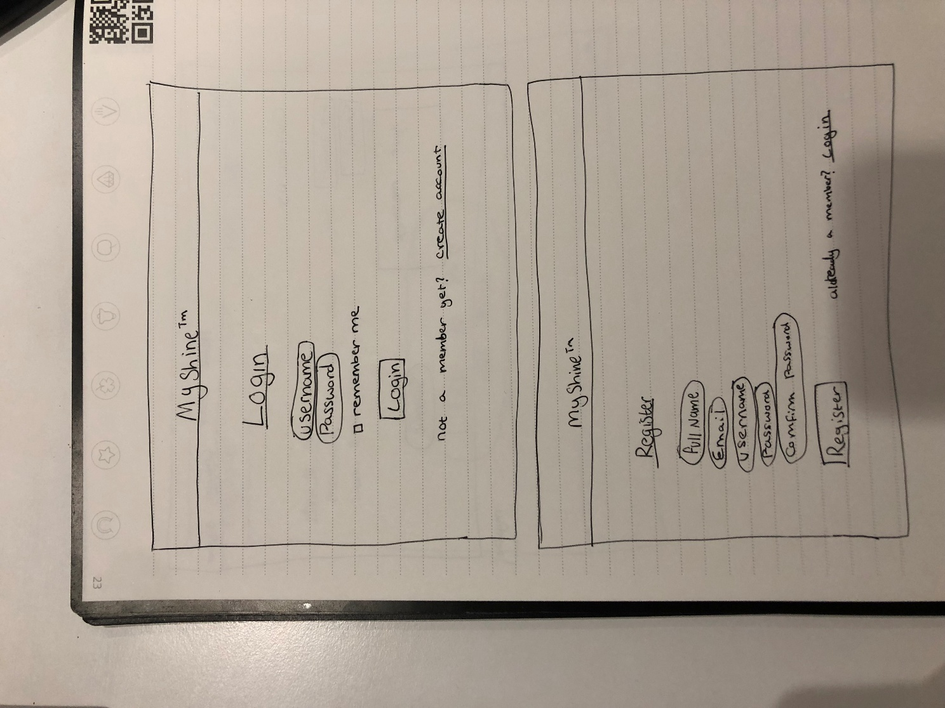

Fields state data desired.

Friendly language to invite interaction.

Confirmation of password reduces misspelling.

**Relevant Heuristics & UX Guidelines**

1. **Visibility of System Status**  
   Users can clearly see what needs to be done at each stage thanks to the form fields' organization and the obvious "Login" and "Register" buttons.
2. **Match Between System and the Real World**  
   The inclusion of well-known terms like "Email," "Username," and "Password" in the form aligns with the user's expectations of how account creation normally operates.
3. **Recognition Rather Than Recall**  
   By making it immediately clear what information is needed, labels are positioned either inside or above form fields, which lessens the memory load.
4. **Consistency and Standards**  
   The design is instantly intuitive because it makes use of standard user interface patterns, such as login and registration formats that are recognizable from many other apps (as well as with each other as they share a common template).
5. **Error Prevention**  
   Both the "Password" and "Confirm Password" sections are included to help users avoid typing mistakes and make sure they have entered their password correctly.
6. **Aesthetic and Minimalist Design**  
   Users can concentrate on finishing the task because both pages are clear and uncluttered, displaying only the most important fields.
7. **User Control and Freedom**  
   Users can navigate between the two forms with ease thanks to clear links like "Create Account" and "Already a member? Login," which keep them from getting trapped.

##### Home Page

The primary control centre for the ‘MyShine’ smart lighting system is the Home Page, which is called Light Centre. An interactive interface greets users, allowing them to observe and control their current light arrangement using straightforward Turn ON and Turn OFF buttons. Users can navigate between various lighting fixtures or rooms by using the navigation controls marked Previous Light and Next Light.

Lighting control is centralized in one convenient spot as a result. Because of its efficiency-focused design, users may easily modify their surroundings. Clear navigation and simple visual cues (like a lightbulb indicator indicating its condition) improve the experience by providing visibility and control.

Clear header which underlines current page.

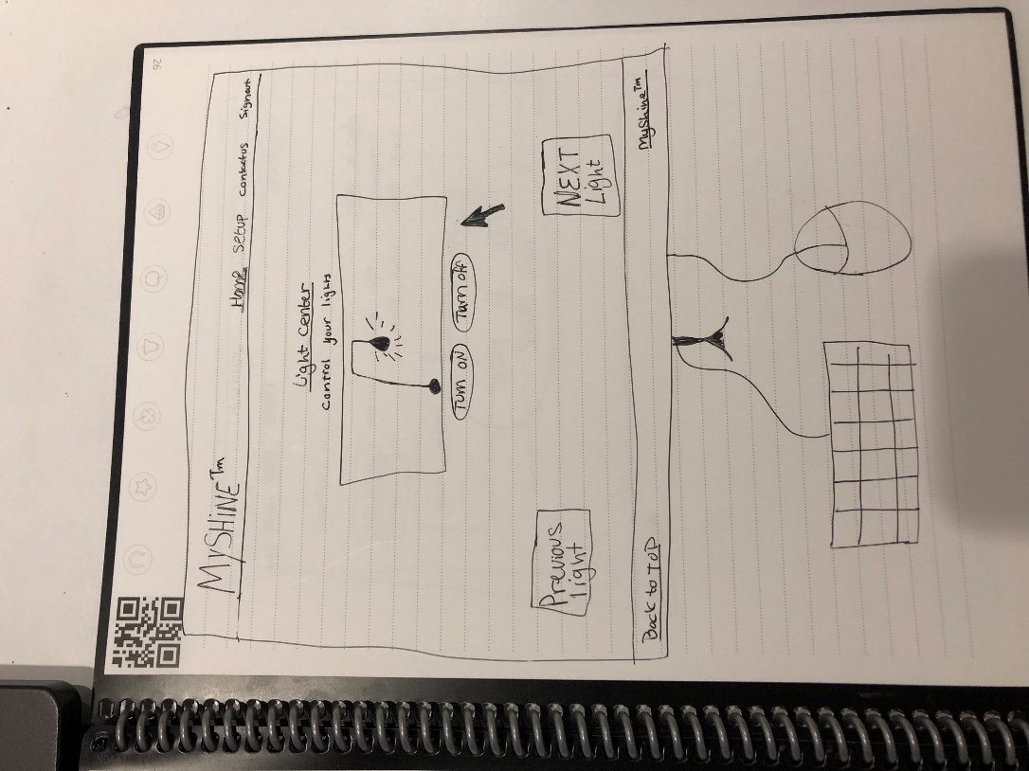

Light status shown through clear animation of light bulb shining.

‘Next’ on right side and ‘Previous’ on left side to coincide with western cultural standards.

Footer follows same design as header.

Clear button labels.

Main function is centred for maximum attention.

‘Back to top’ option to remove need to scroll up.

**Relevant Heuristics & UX Guidelines**

1. **Visibility of System Status**  
   After hitting the buttons, customers receive instant indication on whether the light is on or off thanks to the light bulb icon.
2. **Match Between System and the Real World**  
   Using well-known phrases ("Turn ON", "Turn OFF") and visual aids (light bulb), the design simulates the actual act of turning a light on or off.
3. **Recognition Rather Than Recall**  
   Because each control (such as "Next Light") is prominently displayed on the screen and has a clear label, users can quickly see the actions that are available without having to memorize commands.
4. **Consistency and Standards**  
   Ensures familiarity and ease of use by adhering to standard smart home interface patterns, which include central control buttons, navigation options, and unambiguous labels.
5. **User Control and Freedom**  
   Flexible control over one's surroundings is encouraged by the ability for users to switch between various lights and freely turn any of them on or off.
6. **Aesthetic and Minimalist Design**  
   Only the most important components—the current light, its settings, and navigation options—are visible on the simple interface. As a result, the user is less distracted and maintains task focus.

##### Set up devices

Users can pair new smart lighting products with the ‘MyShine’ system via the Setup Page. A large "Click to Pair New Device" button follows a section titled "How to Pair" that offers educational content explaining the process to do so (to be added in the final version).

When setting up the system initially and adding further lights or accessories, this page is crucial. Even non-technical users can onboard new devices with no difficulty thanks to the design's isolation of the setup process to a clear, focused interface.

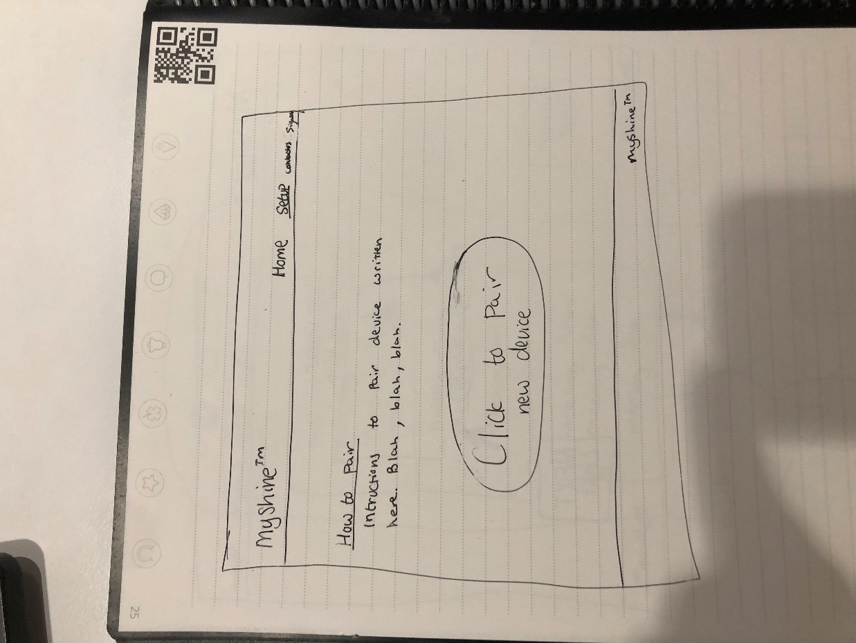

Current page title is underlined in header.

Instructions will be written in easy-to-understand friendly language.

Button to pair in highly visible position and very large to give focus and reduce chance of mis click.

Optimised to reduce number of actions to complete goal; So, there is just one pair button.

**Relevant Heuristics & UX Guidelines**

1. **Recognition Rather Than Recall**  
   A sizable action button and unambiguous on-screen text serve as user guides. They do not have to recall any steps because everything is explained in advance.
2. **Help and Documentation**  
   This website is specifically devoted to instructions, providing assistance to visitors who might require direction. The placeholder "Blah, blah, blah" indicates where step-by-step assistance will be given, even in this prototype.
3. **Aesthetic and Minimalist Design**  
   Only necessary actions and pairing-related information are displayed on the clear interface. This lessens mental strain and focuses attention on the primary task, which is pairing a device.
4. **User Control and Freedom**  
   The user gains control thanks to an obvious "Click to Pair" button. In order to preserve their sense of agency, users can decide when to start pairing.
5. **Consistency and Standards**  
   reinforces familiarity and minimizes confusion by keeping the header and branding layout consistent with other pages.

##### Contact us

Users can submit questions or comments straight through the site by visiting the Contact Us page. With placeholder text showing where the user should interact with the form. It has three fields for the user to fill out, “Full name”, “Email” and "Your message". Accessibility and ease of use are given top priority on this page, guaranteeing that users may contact help without leaving the app.

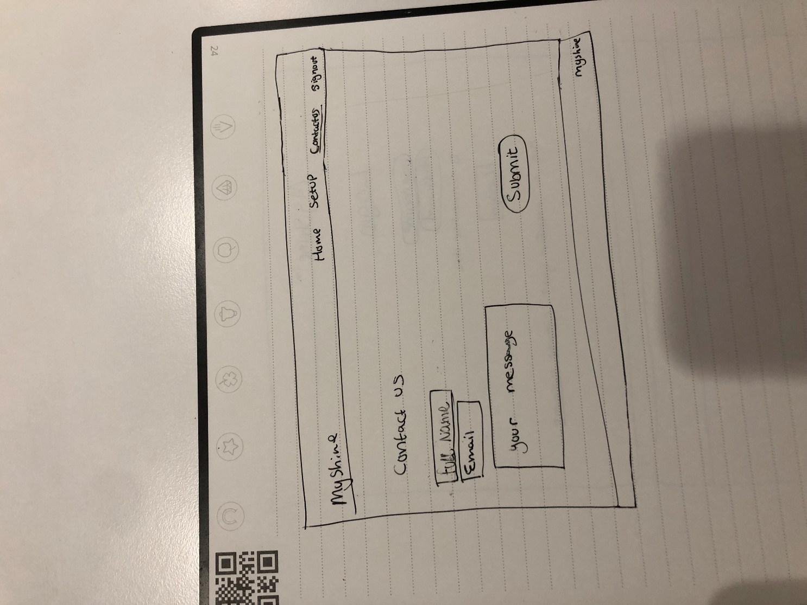

Sign out option to be redirected to log in page.

Consistency with header and page title being underlined.

Fields made clear and easy to understand what data they house.

Submit button positioned in clear view.

‘Your message’ field allows users to enter what ever they would like instead of set number of options.

**Relevant Heuristics & UX Guidelines**

1. **Recognition Rather Than Recall**

Users do not have to remember how to submit queries thanks to fields that are clearly labelled ("Your message") and contact choices ("Home," "Email").

1. **Help and Documentation**

Process is made very simple with placeholder texts suggesting to the user what to input, removes the need for more expansive descriptions.

1. **Aesthetic and Minimalist Design**

The interface is reduced to its most basic components (contact choices, message entry), which helps to focus attention on the task at hand and lessen cognitive burden.

1. **User Control and Freedom**

Users are able to submit almost anything into the ‘message’ box, preserving their sense of agency as they do not need to select from a number of readymade choices that may not apply to them.

1. **Consistency and Standards**

In order to ensure familiarity and easy navigation, the page adheres to the same header and footer design and layout principles as the other pages.

#### High Fidelity

The high-fidelity prototype of ‘MyShine’, a user-focused smart lighting control app made to streamline home lighting automation, is shown in this part. Building on the initial low-fidelity wireframes, the final visual and interactive components are displayed in the polished interface to provide:

1. **Real-World Functionality** – Dynamic product listings, interactive controls (like "Click to turn ON/OFF"), and verified user flows (like login and registration)).
2. **Brand Identity** – All screens use the same font, colour palette, and tone ("Lighting made easy").
3. **Enhanced Usability** – Feedback features, contextual assistance ("How to Set up"), and user-friendly navigation (constant menus).

Key screens include:

* **Device Control Dashboard**: Central hub for light management with status toggles and pairing instructions.
* **E-Commerce Integration**: Product catalogue featuring suggested similar items and prices.
* **Brand Story & Contact**: Adds help options and founder stories to humanise the app.
* **User Authentication**: Streamlined sign-up/login flows with password security.

This prototype adds market-ready improvements while validating the app's visual appeal and work efficiency in accordance with Nielsen's guidelines.

A few big changes were conducted from the low fidelity prototype; This includes the amalgamation of the ‘Home’ page and ‘Setup’ page. This reduces the actions needed to pair new devices as the home page is the landing page after successfully logging in. Another fundamental change, was the addition of the ‘Products’ page which aims to provide users with a simple catalogue of MyShine compatible devices.

##### Home Page

Users may manage paired devices, operate their smart lighting system, and browse more items all from the Home Page. It supports both current users and new clients by skilfully fusing marketing content with functionality.

Evolved from the low fidelity prototype, this combines the set up page within its functions.

Lights in the living room, kitchen, and bedroom may all be directly toggled by users. Among the options are:

* Toggles that turn on and off
* Control the LED colour from colour wheel (if compatible)

This meets user expectations for smart home interfaces by placing a high value on ease of use and direct communication.

Add New Device Section  
Clearly instructs the user to "Pair New Device" in order to add more lights, positioned in the middle for accessibility and visibility.

Product Discovery Section – “Grow your MyShine™ Family”  
Focuses on suggested products to help customers grow their system. In addition to promoting upsells, this keeps content relevant for existing customers.

Lifestyle Imagery – “Control your Life”  
The brand principles of comfort, ease, and modern living are reinforced by a marketing banner that features serene, realistic imagery.

Social Proof – “What do other users think...”  
Includes user reviews. This increases engagement, fosters trust, and adheres to UX best practices for legitimacy.

Friendly and clear title names.

Sign out option is given extra attention.

Image of lamp increases clarity and gives the system a more personal feel.

Connectivity status clear.

Custom names and descriptions to give users more freedom.

Ability to turn on/off device and adjust colour.

Instructions for pairing new devices uses simple language and reduced steps to complete.

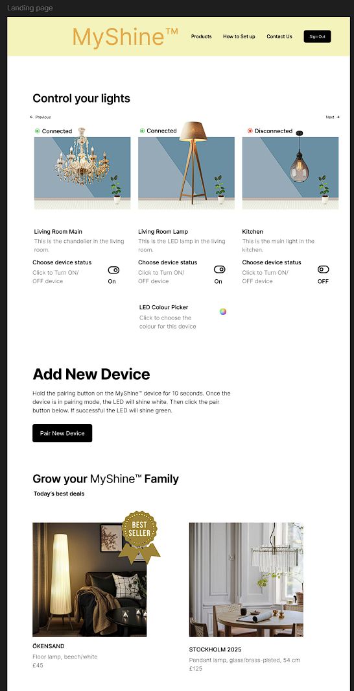

Special offers shown to users to promote products.

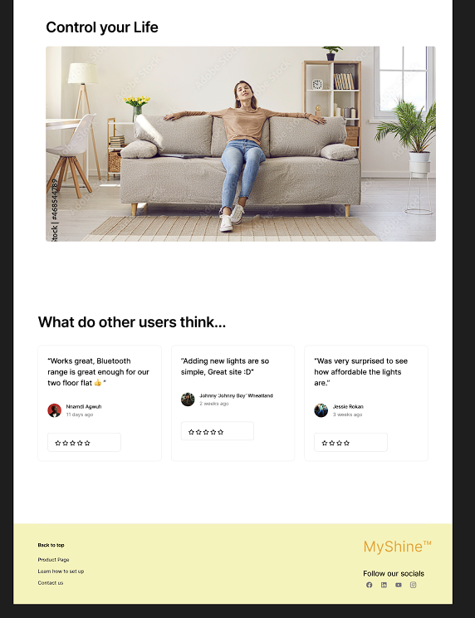

Continuation of ‘Control your’ motif which conveys to user this service’s main goal is to give users urgency and control over their home.

Customers reviews show positive take away from the brand which comforts users and increases trust in service.

Link to brands social medias to increase customer loyalty.

Footer is in the same style as the header, which has the option to return to the top of the page.

**Relevant Heuristics & UX Guidelines**

1. **Match Between System and Real World**  
   makes use of natural language and simple lighting controls (such as colour wheels and "ON/OFF" buttons) that mimic activities in the actual world.
2. **Visibility of System Status**  
   Transparency and user confidence are increased because users may observe their lights' status instantaneously (e.g., ON/OFF).
3. **Aesthetic and Minimalist Design**  
   The page stays clear of clutter despite having a wealth of information. To strike a balance between usability and aesthetic appeal, the layout makes use of clear parts, lots of whitespace, and subdued colour schemes.
4. **User Control and Freedom**  
   The user is always in control; every action, whether it is turning on lights, installing a new gadget, or looking at things, is intentional and reversible.
5. **Recognition Rather Than Recall**  
   Labels, iconography, and recurring layouts (such as device cards) make it easier for users to navigate the interface without having to recall past activities.

##### Products Page

This page provides detailed information about a specific smart lighting product (e.g., the “ARSTID” lamp). It is designed to support decision-making by giving users all the information they need to evaluate and purchase a light compatible with the MyShine™ system.

Prominent Product Image  
The top-left image of the lamp draws the user's attention right away and presents the item in an authentic environment. This makes it easier for customers to see the product in their own settings.

Product Title and Description  
A brief product slogan or ID (such as "Lamps for smart homes") and the title ("ARSTID") provide immediate context. This facilitates scannability for speedy judgment.

Price Display  
A crucial component of any product page is the price, which is displayed prominently (e.g., £19). It promotes transparency and prevents misunderstandings.

Related Products Section  
A grid of extra products (such as "STORSINT," "ROTERA," "LAMPIS," etc.) encourages cross-selling and upselling. Users can investigate complimentary or similar lighting, which improves the discoverability of products.

Consistent Branding  
The footer and navigation offer a smooth transition from the Home Page while preserving the brand identity (MyShine logo and social links).

Free shipping option influences customers to purchase more lights than they may have originally planned.

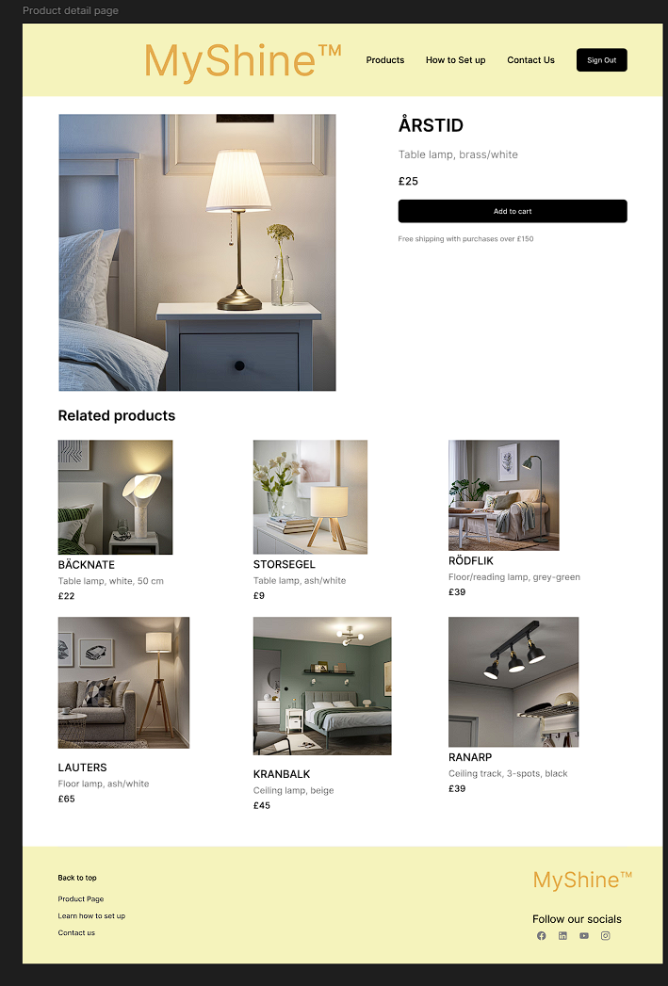

Related products increase chance multiple purchases.

Minimalist layout for each product lets each product speak for itself.

Consistent font, text size and layout.

**Relevant Heuristics & UX Guidelines**

1. **Consistency and Standards**  
   Consistency in layout, colour palettes, and text styling with the rest of the application reinforces familiarity and ease of use.
2. **Recognition Over Recall**  
   The price tags, product titles, and images are made to be easily identifiable. This helps users compare quickly and relieves cognitive pressure.
3. **Aesthetic and Minimalist Design**  
   Information overload does not exist. In keeping with the minimalist philosophy, only pertinent details are displayed. Additionally, the Related Products section maintains its grid alignment and cleanliness.
4. **Help Users Recognize, Diagnose, and Recover from Errors**  
   The design minimizes the possibility of user error by avoiding confusing CTAs or overloaded options.
5. **User Control and Easy Navigation**  
   Users have the option to explore additional products or leave at any moment. Users feel in control thanks to the clear grid and prominent content.

##### Contact us

By telling the MyShine™ story, this page increases user confidence and brand trust. Additionally, it enables people to get in touch with the staff directly, which humanizes and opens up the brand.

About Section ("Our Story")  
A brief story outlining the inception or vision of MyShine is presented on the left. This fortifies the brand identity and forges an emotional bond.

Founder Image  
The product is made more relatable by including a circular photo of the creator. Seeing a genuine person connected to the brand increases credibility and authenticity.

Contact Form  
A simple form includes fields for:

* Name
* Email
* Subject
* Message

This makes it simple for people to contact us for help, questions, or comments. The "Submit" button is prominent and easy to find.

Consistent Layout & Navigation  
The footer and navigation bar are the same as on other pages. Social media buttons are once more included in the bottom, preserving connection choices throughout the website.

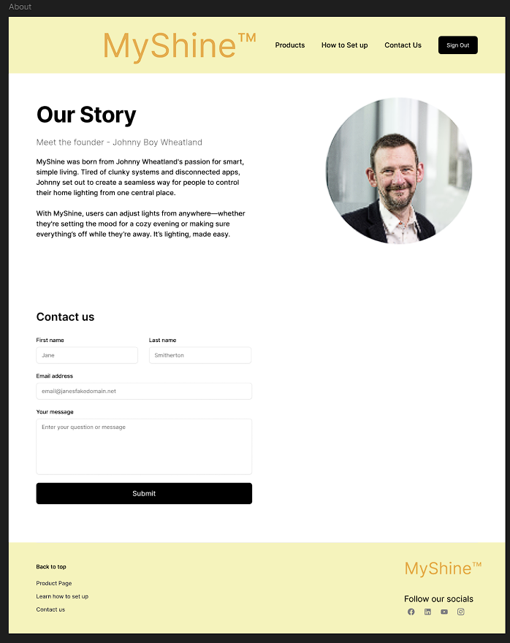

Inviting interaction.

Simple to navigate form.

‘Our Story’ humanises the brand as a dream of a humble man instead of a cold machine.

Image of founder adds personal touch.

**Relevant Heuristics & UX Guidelines**

1. **Match Between System and the Real World**  
   A personal tone that fits with the practical demands of openness in contemporary digital brands is provided by the founder's persona and narrative.
2. **Visibility of System Status**  
   The layout of the contact form makes it obvious what the user needs to do. Users see exactly what they need to perform and are not overloaded with options.
3. **Aesthetic and Minimalist Design**  
   The website makes good use of white space and steers clear of visual clutter. The content strikes a good mix between utility and narrative.
4. **Flexibility and Efficiency of Use**  
   Both exploratory and goal-directed users are supported by the option for returning users or those who are already familiar with the brand to skip the story and go directly to the contact form.
5. **Help and Documentation**  
   Although it is not typical help, the story and contact form work together to enable users who need help or more details while keeping support relevant to the user's situation.

##### Register

In order to fully utilize the MyShine platform, including syncing items, receiving updates, and remembering device preferences, new users can create an account on this page.

Form Fields:

* Full Name
* Email Address
* Password
* Confirm Password

The form is brief and includes all of the information needed to create an account. It keeps users from being overloaded with fields.

Create Account Button

* A clearly styled "Sign Up" button invites users to complete registration.
* An alternate link — "Already have an account? Log in here" — supports returning users who may have landed on this page by mistake.

Privacy Notice  
Users are informed in a brief statement that they accept the terms of service or privacy policies by registering. Being open about user rights is an example of ethical design.

Consistent Design

The page sticks to the prototype's distinctive yellow header and footer style.

To keep attention on the form, the MyShine logo and navigation bar are there but not intrusive.

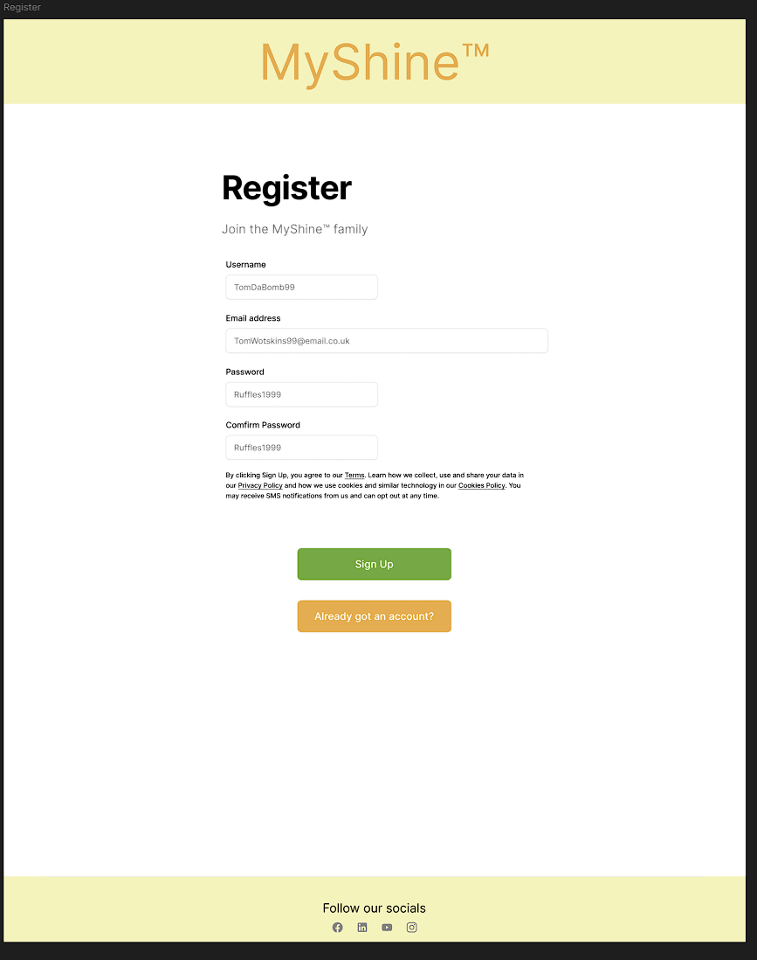

Link to Login page.

Confirm password to reduce chance of error.

Friendly language.

Easy to navigate form.

Privacy policy shared with user to comply with GDRP.

**Relevant Heuristics & UX Guidelines**

1. **User Control and Freedom**

In order to avoid unintentional re-registration, users are offered the option to log in if they already have an account.

1. **Error Prevention**

The chance of credentials being typed incorrectly is decreased by including both the Password and Confirm Password sections. Although not shown in the prototype, input fields probably involve validation (e.g., valid email forms, minimum password length).

1. **Consistency and Standards**

The layout of the form is standard for contemporary web platforms, which reduces the learning curve and fosters confidence.

1. **Recognition Rather Than Recall**

Each field has a clear, descriptive label. Additionally, the option to redirect the login is explained, which lowers the memory burden.

1. **Aesthetic and Minimalist Design**

Only the information that is required is gathered. Vertical alignment is used in the layout to improve readability and responsiveness on mobile devices.

##### Login

Returning customers can safely log in to their MyShine account on this page to enjoy customized features including customizing their home lighting configuration, controlling associated devices, and seeing saved preferences.

**Login Form**

* The fields for email address and password offer a straightforward and easy way to log in.
* For convenience, a "Remember Me" tick enables users to remain logged in on reliable devices.

**Login Button**

* The main action is highlighted by a bright orange "Log In" button.

**Redirect to Registration**

* In order to facilitate a seamless onboarding process, the "Create New Account" button enables new users who have accidentally landed here to swiftly navigate to the registration page.

**Minimal Distractions**

* In contrast to pages with a lot of material, this screen is intentionally simple to draw attention to user authentication.
* The footer and navigation are still available but do not take precedence over the primary activity.

Link to register page.

Friendly language.

Remember me check box reduces need to log in with every visit.

Same layout as register page.

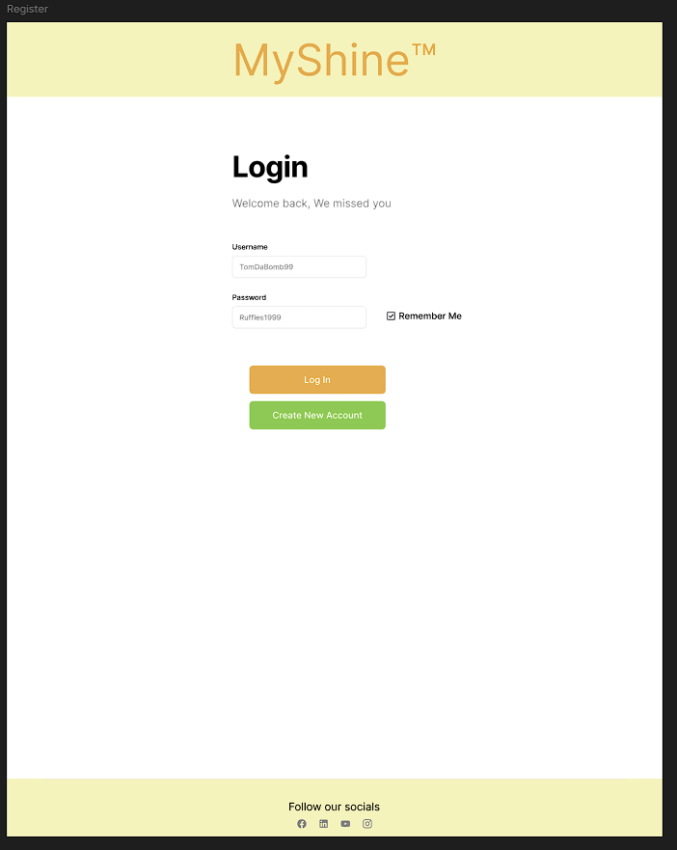

**Relevant Heuristics & UX Guidelines**

1. **Visibility of System Status**

The design allows for feedback (such as unsuccessful login attempts), informing users.

1. **Match Between System and the Real World**

Users are accustomed to the wording used in field labels such as "Email" and "Password."

1. **User Control and Freedom**

For people who have not joined up yet, the option to register offers a way out.

1. **Recognition Rather Than Recall**

Users do not have to recall what to do thanks to input labels and buttons that are easy to see.

1. **Aesthetic and Minimalist Design**

White space and a simple layout guarantee that consumers are not distracted and can concentrate on logging in.

## Part 3 - Functional, responsive front-end UI

### User Goals

The primary user goals implemented in this interface are:

1. **Light Control Management**:
   * View all connected smart lighting devices
   * Toggle individual lights on/off with visual feedback
   * Identify connection status of devices
   * Scroll through devices with intuitive navigation
2. **Device Pairing**:
   * Add new MyShine™ devices to the system
   * Follow clear pairing instructions
   * Receive feedback during pairing process
3. **User Authentication**:
   * Register new accounts
   * Log in to existing accounts
   * Maintain session until explicit sign out
4. **Customer Support**:
   * Contact company support team via form
   * Access alternative contact methods
   * Learn about company background

### Implementation Techniques

**Repository Link**: <https://github.com/Ashhuby/UIUX>

Key implementation techniques used:

1. **Responsive Design**:
   * Flexible containers with max-width constraints
   * Percentage-based widths and viewport units
   * Media queries for adaptive layouts
   * Touch-friendly interactive elements
2. **Interactive Components**:
   * Custom toggle switches with CSS transitions
   * Horizontal scrolling device carousel
   * Form validation and submission feedback
   * Audio feedback for user actions
3. **Visual Hierarchy**:
   * Consistent colour scheme (#ffcc00 as primary)
   * Clear section headings and content organization
   * Visual feedback for interactive elements
   * Error states for disconnected devices
4. **Navigation**:
   * Persistent header navigation
   * Clear call-to-action buttons
   * Back-to-top functionality
   * Consistent footer across pages

### Storyboard Sequence

**1. Login Page**  
The user is presented with a simple, uncluttered login screen. There are obvious options to log in or create a new account.

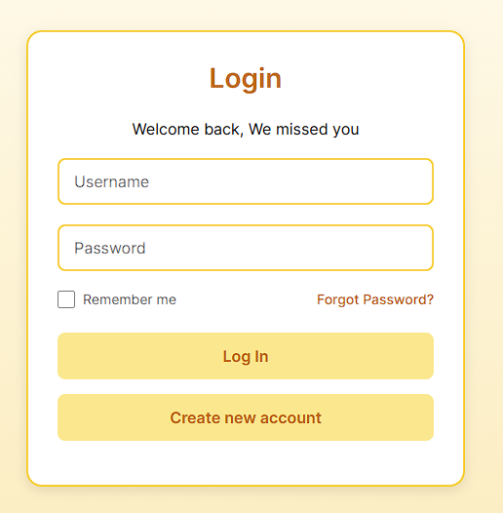

**2. Main Dashboard (Initial View)**  
The user sees the dashboard after logging in. A carousel that can be scrolled horizontally is used to display smart lights. Toggle switches display the ON/OFF status in real time.

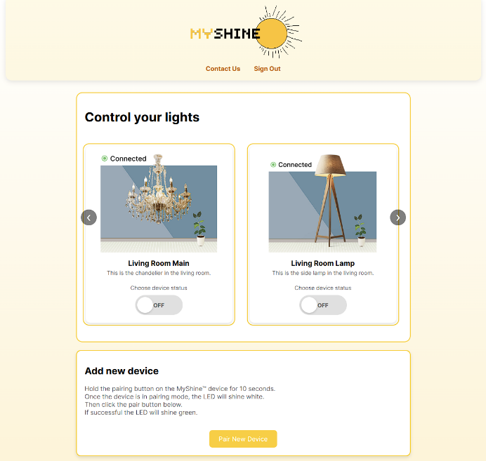

**3. Scroll Through Devices**  
The user locates the required gadget by scrolling through the carousel. To move between cards, utilize swipe movements or arrow buttons.

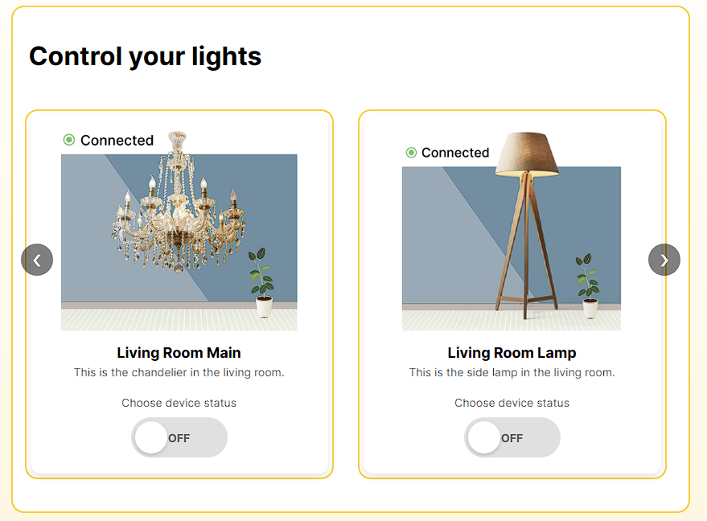

Navigation button is pressed.



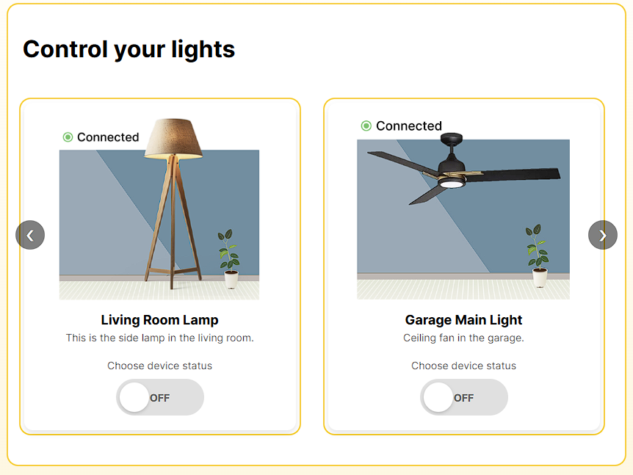

**4.Toggle Light ON**  
The toggle button under "Garage Main Light" is clicked by the user. With a visible state change and a confirmation auditory cue, the switch updates to "ON."

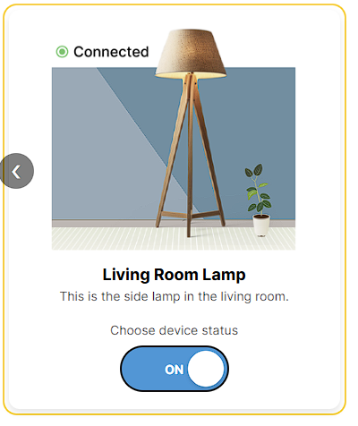

**5. Toggle Light OFF**  
To turn off the light, the user presses the toggle once more. The user interface (UI) verifies the action with feedback and changes to reflect the OFF state.

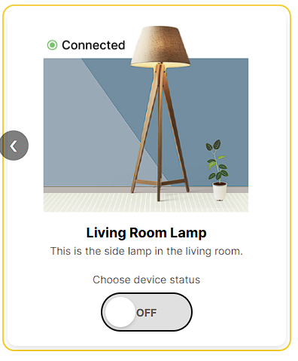

**6. Device Pairing**  
The device pairing interface is accessed by the user. They are guided through the procedure with clear directions, and after a successful pairing, they are presented with a confirmation dialog.

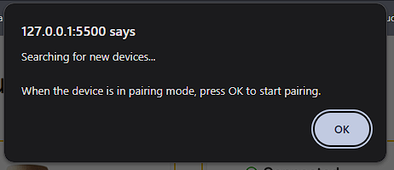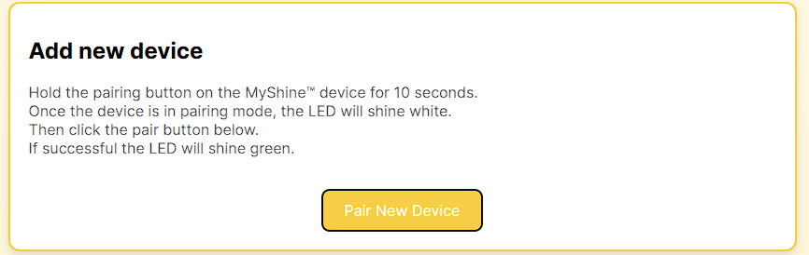

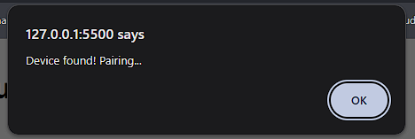

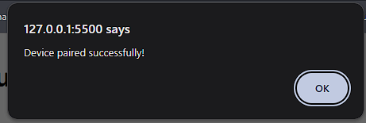

**7. Contact Page**  
The user accesses the Contact page. After validating input fields, the form shows a success or error message depending on the outcome.

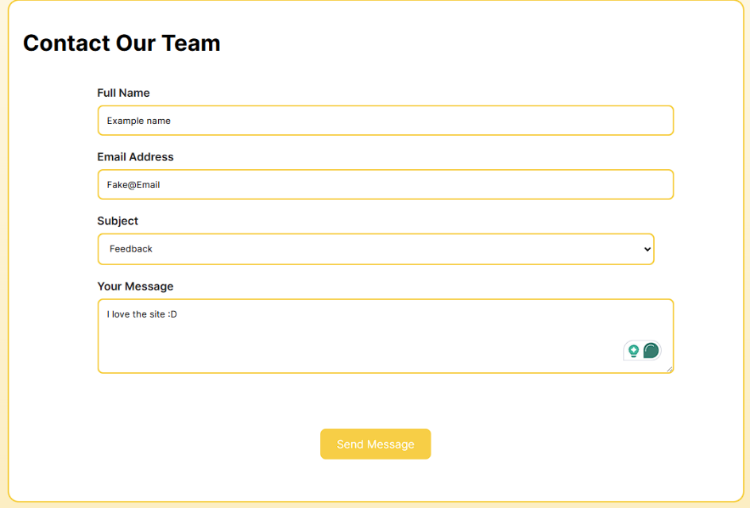

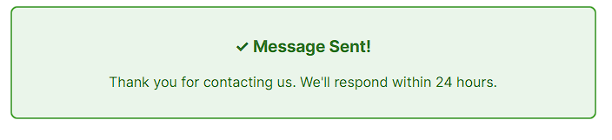

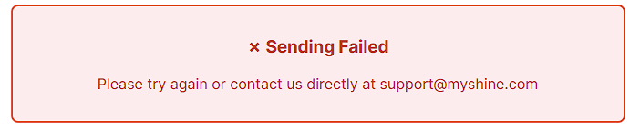

Video Walkthrough

For all my ACW’s I create videos showcasing the assignment, as well as a walkthrough it also acts as a more general reflection.

Video can be found in [UIUX\Part3- MyShine Website\Video]

### Implementation Reflection

##### Successes:

1. **Achieved Goals**:
   * Created intuitive light control interface
   * Implemented responsive design across devices
   * Delivered consistent visual language
2. **Technical Implementation**:
   * Custom toggle switches with smooth animations
   * Effective horizontal scrolling solution
   * Comprehensive form handling

##### Compromises from Initial Design:

1. **Simplified Device Management**:
   * Originally planned grouping functionality was deferred
   * Scheduled lighting controls not implemented
2. **Authentication**:
   * Actual backend integration replaced with frontend mock-up
   * Password recovery flow not fully developed
3. **Visual Design**:
   * Reduced animation complexity for performance
   * Simplified some interactive elements for mobile

##### Areas for Improvement:

1. **Enhanced Device Controls**:
   * Add brightness/dimming functionality
   * Implement colour control for RGB lights
2. **User Experience**:
   * Add loading states for device communication
   * Improve error handling for connection issues
3. **Accessibility**:
   * Enhance screen reader support
   * Add more descriptive labels

**Conclusion**:  
The approach preserves a clear, responsive interface while effectively meeting the major user objectives. The current version offers a strong basis for future improvements, even though some of the more sophisticated features from the original plan were postponed. A targeted, useable product that satisfies the needs of the main user base was produced by striking a balance between feature richness and timely delivery.

## Part 4 - User testing and feedback on functional front-end interface

Tester name: Nnamdi Agwuh

Ethics check location: [UIUX\Part4 -Testing\Checklist]

Chosen testing method: Think-Aloud protocol

Test transcript location: [UIUX\Part4 -Testing]

##### Rationale for chosen method:

I decided to use the Think-Aloud Protocol, a qualitative usability assessment technique, for this test. Because it reveals how users think, what they expect, and where they get confused while engaging with the prototype, this method is perfect for early-stage or formative testing.

By encouraging the user to verbalize their thoughts while attempting to turn on the light through the website interface, I can directly observe:

* What the user is looking for on the screen.
* Whether they understand the meaning of buttons, labels, or icons.
* Any points of hesitation or misunderstanding.

The rationale for choosing Think-Aloud is that it provides deep insight into the user’s mental model — what they believe the system will do versus what it does. Understanding user expectations and decision-making is crucial to enhancing the interface's clarity and usability because this task includes a straightforward yet crucial interaction ("Turn on the light").

This approach is also very efficient when testing with a limited number of users, which is appropriate for the assignment's context (peer testing with a single participant), quick to execute, and does not require any special equipment.

### Test 1: Turn on garage light

User goal: The user should attempt to turn on the ‘Garage Main Light’ using the MyShine web interface.

Assumptions/Conditions:

* User has successfully logged onto the MyShine dashboard.
* There are devices already added to the dashboard, including ‘Garage Main Light’.
* Website is setup on a laptop using a keyboard and wired mouse.
* User has at least the average level of technical literacy.
* User has no experience with the website.

##### Test Reflection:

The Think-Aloud session was conducted with Nnamdi, a fellow student, using the MyShine website. The task was to "turn on the garage main light."

Positive Observations:

* The participant grasped the task quickly and used the confidently navigated the interface.
* He was able to locate the correct section after minimal exploration and used the arrow navigation without issue.
* He was able to locate the toggle button and use it to activate the light.
* He made complimentary remarks on the dashboard's visual style, usability, and layout, stating that it was both visually consistent with the theme and easy to use.

Minor Usability Insight:

* The user observed that when the light was turned on, a click sound was produced; however, when the light was turned off, no sound was produced. He proposed that the user experience would be enhanced by including a consistent auditory signal for both actions.
* Even though this feedback is small, it emphasizes how crucial continuous audio feedback is for reinforcing user behaviours.

##### Improvements Made:

**Added Toggle-Off Sound Feedback**

Currently, an audio confirmation only plays when the user turns on a device in the MyShine dashboard. This has been changed so the same audio cue plays for both statues of the toggle button. This increases the clarity of interactions and guarantees constant feedback.

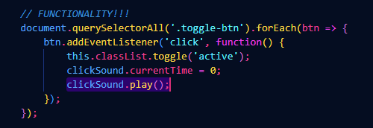



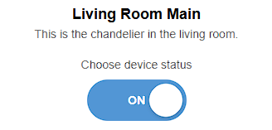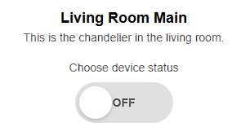



Audio que now plays for both turning on and off device.

### Test 2: Submit contact us form

User goal: The user should attempt to submit an UI suggestion/feedback through the MyShine contact page.

Assumptions/Conditions:

* User has successfully logged onto the MyShine contact us page.
* Website is setup on a laptop using a keyboard and trackpad.
* User has at least the average level of technical literacy.
* User has no experience with the MyShine contact us webpage.

##### Test Reflection:

This test assessed the user's ability to successfully submit a user interface recommendation using the "Contact Us" page.

**Positive Observations:**

* Without assistance, the user recognised the contact form right away and knew what each field was used for.
* There was no need for further explanation because the form's layout and labels were obvious.
* The user could quickly understand the visual feedback on submission ("sending", "failed", and "sent" messages).
* The "Our Story" section received a favourable response from the participant, who called it "wholesome" and mentioned how user-friendly the page was.

**Minor Usability Insight:**

* Although there was no specific option for "Website Feedback" in the subject field, the user still wanted to provide input about the website.
* Although the participant chose "Other," they pointed out that feedback is a frequent enough action to maybe merit its own category.

##### Improvements Made:

**Added ‘Website Feedback’ to Subject Dropdown**

A new option for "Website Feedback" was added to the subject field in response to the user's comments. This enhances clarity and helps match the form options with typical user intents.

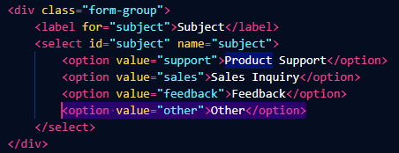

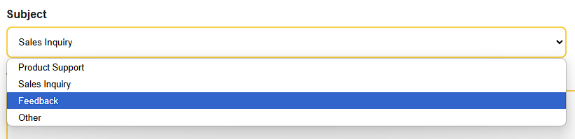

New ‘Feedback’ subject option added to drop down.